St. Elizabeth Ann Seton Catholic Church 4595 Snyder Lane Rohnert Park, CA 94928 (707) 585-3708 Website:www.Stelizabethrp.com E-Mail stelizseton@sbcglobal.net Office Hours: Tue.- Fri. 9am - 1pm The Church is open daily 7:30am-7pm

October 18, 2026

29th Sunday in Ordinary Time

Parish Staff
Pastor: Rev. Thomas Diaz #4 Office Manager: Chris Giacometti: #1
Mass times: #2
Youth Faith Formation: Jennifer Bedoka #3
Executive Board: Tony Madia/Chairperson, Linda Biondini/Vice Chairperson, Katie Chase, Larry Ruminson, Diane Colbrook
Floral Decorations: Cesira Rantissi Heric
(707)338-3959
Sacraments and Devotions
Reconciliation: Sundays: 9:45-10:15am,
Thu 1-1:30pm
Marriage: One year notice to the pastor.
Infant Baptism: The next preparation session Sun., Oct 25th at 1:30/hall and you must register in advance.
Anointing of the Sick: Please call Fr. Tom. Usually, it is celebrated after 10:30 Sunday Mass
The Rosary: ½ hr. before weekday Masses.
Divine Chaplet: Tuesdays after the12:15 Mass
Exposition & Benediction: Thu.12:45-1:45pm.
The Welcoming Church: Wed. 6pm/Hall

Mass Schedule and Intentions for the Week
Sat/Oct 17 4pm +Abel Sagon
Sun/Oct 18 8:30am People of the Parish
10:30am Ints for Summit Schreck
3pm Filipino Saints Day Mass
Tue/Oct 20 12:15pm Ints for Lorraine Datu
Wed/Oct 21 8:15am Ints for Lorraine Datu
Thu/Oct 22 12:15pm Ints for Maureen Weissman
Fri/Oct 23 8:15am For All Priests
Sat/Oct 24 4pm +Moyra Moy
Sun/Oct 25 8:30am People of the Parish
10:30am

Events in the Parish this Week
Sun/Oct 18, 10:30am Liturgy of the Word for Children
1:30am Hispanic Ministry Mtg/Hall
3pm Filipino Saints Day Mass
Afterwards Celebration/ Hall
Wed/Oct 21 6pm Welcoming Church/Hall “What is conversion?”
Special Future Events
Sat/Oct 24 on Taking Tamale Order after the masses
Sun/Oct 25 9:30> Men’s Club Breakfast

1:30pm Baptismal Class/Hall You must register in advance
Tue/Oct 27 5:30 Living Rosary
Wed/Oct 28 Noon Monthly Potluck Sun/Nov 1 11:30 Saints Day Carnival Sat/Sun Nov 7-8 Women’s Guild Xmas Crafts Faire Taking Tamale Order after the masses Sat-Sun/Nov 13-14 Tamale Pick-up

Stewardship for October 10th & 11th: Plate $4,382
Not quite there yet! Thank you for your generosity for Building Maintenance $2,039. Today is Mission Sunday and all throughout the United States, Catholics are asked to show their solidarity with third world countries, and to assist them with this second collection today for the Foreign Missions.

Last Sunday’s Homily Highlights

- The Lord invites all to the Feast in heaven.
- As we hunger for delicious foods do we hunger for the things in Heaven?
- As all are invited, do we show the Lord by our words and actions that we want to go there?
- We need to dress our hearts with dignity, love, justice, and mercy if we plan on going to the feast in Heaven.

Sunday Scripture Readings
Reading I: Isaiah 45:1,4-6, Reading II:1 Thessalonians 1:1-5b, Gospel: Matthew 22:15-21.

Sunday Reflection
There seem to be two realms, God’s and Caesar’s. Jesus says this in Sunday’s Gospel: “Give to God the things that are God’s and to Caesar the things that are Caesar’s. ”Which realm do we live in?”
Are we “Sunday Catholics,” giving to God maybe an hour per week at Mass and then getting on with television and cars and work and food? And maybe with being afraid? Or with wishing things had turned out better? Do you leave it to professionals to pray to God while you live a lesser life? Have we given your life to Caesar? Or do we try it the other way around? Perhaps we are so serious about Christianity and spirituality that we try to get away from enjoyment of any worldly thing so as to live uncorrupted. Through the history of Christianity there have been marvelous examples of this. The desert hermits. The cloistered nuns and monks. The great mystics. “A penny for Caesar and all the rest for God”? If you push this statement too far, everything of Caesar must go away because it is not God, or on the other hand, God has to go away because science and secularism are so powerful. Maybe Jesus made his statement to settle the argument posed to him by Pharisees. Here is a key. Can God and Caesar co-exist? What if you are created to be a container for God’s presence right in the midst of the secular world? What if, in spite of the voices within you saying that you are not worth much, in spite of the setbacks of life, the losses, the flatness, in spite of all these, what if God created you with room inside you where God, out of love for you, can be quietly present? I can hear objections to such an idea: “God would never be at home in me, not until I do a lot better with my life.” Or, “You want me to be some kind of nut, running around acting holy?” Or, “Sure, I want to let God in, but I like beer and TV too much.” Or, “What does all this have to do with real life?” Or simply, “I don’t want to.” But if God were a great friend, a loving, faithful amigo who really does want to be with you, within you, as much as is possible? In fact, how would it be if God were a companion who truly and actually accepts you and forgives you completely whenever you need it? Wouldn’t this give you another way to look at the connection between heaven and at earth? Wouldn’t it mean that God put you and me into the world to be holy in it, to be friends with the things of Caesar? To work in the world of sin in spite of our own sins? Could be that we ourselves are those “things that belong to God” that Jesus spoke of. “Belong,” not in a possessive way, but in the way felt by people who love and are loved. We “belong.” If this were so, why wouldn’t we want to give ourselves to God, and then also to bring our God-filled selves to Caesar’s palaces and to the dirty roads outside them and show everyone what Jesus is all about? Which realm should we live in? Both. John Foley, S.J. Discussion Question: In this Gospel reading, are the Pharisees more interested in taxes or in undermining Jesus’ influence? Do God’s and Caesar’s worlds have to be separated? “Can we divorce spiritual obligation from political policies … or social issues?” Family Connection Payment of taxes is unlikely to be a disputed issue in your family. Yet families can still learn something from this Gospel reading. Jesus’ answer to the Herodians and Pharisees redirects their question to focus on the issue of greatest importance: loving and honoring God. Taking this perspective can help us make good judgments about the competing issues of importance in our lives.
In today’s Gospel Jesus reminds us of the necessity of giving things their proper importance. Read Matthew 22:15-21. The Herodians and Pharisees were giving too much importance to the issue of the payment of taxes. Jesus reminds them that loving and honoring God is of greater importance. In family life we do many important things, but we remember that God is of the greatest importance in our lives. Pray together that your family will learn to keep things in proper perspective, remembering to keep God first in your lives. Pray together today’s psalm, Psalm 96.


Quote of the Week
“To always be close to Jesus, that is my life plan.”
Venerable Carlos Acutis

Faith Formation Schedule
Sun., October 18th
9:30am 1st Year Confirmation/CL
5pm Youth Group
Tues., October 20th
3:30pm Catechesis of the Good Shepherd Ages 3-6/Atrium
Wed., October 21st
3:30pm First Communion Level 1/CL
3:30pm First Communion Level 2/CL
Sun., October 25th
9:30am 1st Year Confirmation/CL
5pm 2nd Year Confirmation/CL
Children ages 3-6 are invited to join us as we explore our faith through Catechesis of the Good Shepherd from 3:30-5pm.
Volunteer Opportunities please sign up using the links below: Stamp Mass Cards,
https://www.signupgenius.com/go/10C0D4AA5AF2AA0F9C52-65333187-20262027
Assist Wednesday evenings from 3:15pm-5pm
https://www.signupgenius.com/go/10C0D4AA5AF2AA0F9C52-65333056-20262027
Be on the lookout for these up and coming events in your email. You can email sesreled@gmail.com or text if you want to help and get community service hours!
Living Rosary, Tuesday October 27th
St. Carnival, Sunday November 1st
Do you like to bake? Faith Formation is looking for cakes for our cake walk on November 1st! Please call or text 707-888-9672 if you can help.

Please Pray this week for: Robert Beasly, Joe Arigoni, Bibi Ballesteros, Giselle Barrion, Sarah Bardoni, Catherine Delara, Diva & Gaba Delara, Giovanna DeSimone, John Diaz. Marcella Dorado, Maryann Eger, Marcus Esplada, Jim Estrella, Rosita Faltado, Amanda Fernandez, Janet Fenstermacher, Kathy & Cedric Fontana, Carl Hilton, Nancy and James Keegan, Sue Kennedy, Trinidad Legaspi, Frank Manhoso, Ruth McAllister, Judith Miller, Joseph Patrick, Mary Piccioni, Vivian Pruett, Emi Jade Przyborowski, Linda Sime, Cecilia Tarrant, Diane Thrailkill, Beverly Thomey, Jim Turegano, Tiffany Valentine, Ken Wagy, Steve Werle, and Ray Wilcox. To put a name on the list, please call the office

MEN’S CLUB BREAKFAST Sun. Oct 25th after the Masses. Come and join us as it is free and the company is great!

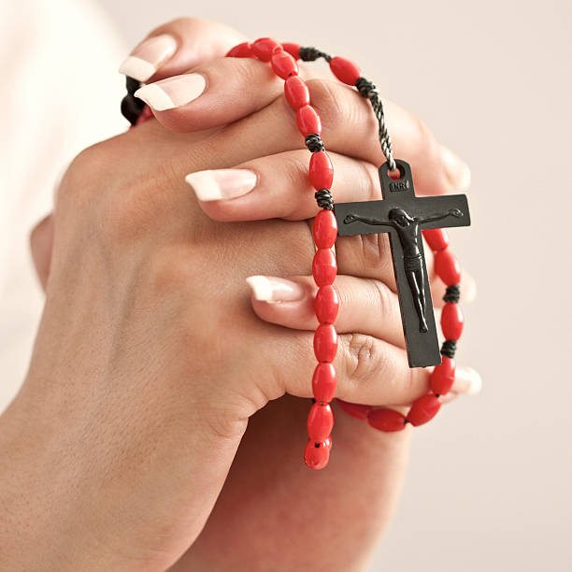
The Living Rosary The parish would like to invite you to join us in the church on Tuesday, October 27th to pray and sing for our departed loved ones. Starting at 5:30pm. You can write your deceased family members and friends on paper angels, as we honor those we have lost.
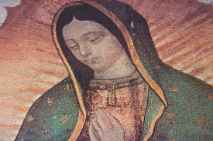
Ministerio Hispano It is that time again! We are going to have our tamales presales starting October 24th through November 7t^{h} after masses. We are only making 50 dozen! So place your orders! Pick up will be November 15t^{h} after the 10:30am Mass. This is to help us pay for the mariachi we will have on December 12th for our Virgen de Guadalupe. Ya se llego la temporada de tamales! Vamos a empezar la preventa de tamales este 24 de octubre después de cada misa. Solo haremos 50 docenas. Así que ordena la tuya cuanto antes la entrega será el 15 de noviembre. Los fondos se utilizarán para pagar el mariachi que tendremos el 12 de diciembre para darle las mañanitas a la virgen de Guadalupe.
Pastor’s Corner
Congratulations to Beth Turegano who was officially announced by Bishop vasa along with other women from the diocese as Women of the Year. I want to thank Tony Turegano who cuts the lawn every week and Sally Shami who waters a lot of our plants every week. I want to thank Dave Grundman for all the quiet work he does. I want to thank those who are in our choirs for the songs they sing at Mass. There are so many more people to thank. Someone left a kneeler next to the office outside door. I thank you for it, but it is not needed, and so please take it home.
St. Elizabeth Ann Seton’s Man of the Year 2026
Is there a man at St. Elizabeth Ann Seton that you feel does an outstanding job that deserves to be recognized? Is he someone that continually offers his time for the betterment of the parish? The Men’s Club is asking parishioners to nominate any man they consider to be qualified to be selected as Man of the Year. This is a parish sponsored event and has no affiliation with the diocese. Nominees must be a registered parishioner and practicing Catholics. Please complete the form below including your phone number should we need more information. Place your completed form in the container provided in the vestibule. Deadline is Sunday, November 1 at noon. A Man of the Year committee will review all nominations and select the Man of the Year. Selected individual will be announced at the masses the weekend of Nov Contact Ron Ciarasso for any questions (707) 529-6932,
Your name (print) _____________________ Your phone: ___________________________
Name of the person you are nominating and the reason for the nomination. ______________________ _______________________________________________________________________________________________________________________________________

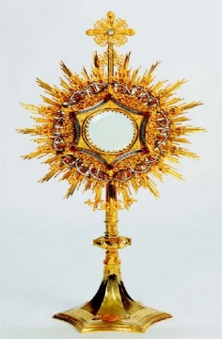
Sonoma State University Newman Center Eucharistic Conference
Sonoma State University Newman Center 2026 Eucharistic Conference: Eucharistic Theological Conference Register early, as seating is limited Friday October 23, ~ 3:30 PM to 8:45 PM Saturday, October 24, ~ 8:00 AM to 8:30 PM Meal options for conference are in process….. Join us for two days of faith, formation, and encounter centered on the Real Presence of Jesus Christ in the Holy Eucharist.
Information sheets are available across from the office.


Social Justice Ministry is conducting a clothing drive for the Unsheltered Friends Outreach (UFO) during this month. The needs are for adults only, about 75% are men. There is a need for boots, men’s shoes, pants, T-shirts and long-sleeved shirts (the types of clothes that can be layered). Please no formal attire. Our parish has shown great generosity to the UFO. God bless you!

Women’s Guild


4th Annual Craft Fair
November 7th, 10am-4pm
November 8th, 9am-1pm
Only Handmade items will be sold.
Preference for space availability
will be given to parishioners.
More info to come later.
Direct questions to:
Julie LaPlante at (707)239-0604 or
Lucy Madia at (707)328-588 St. Vincent de Paul Activity Update:

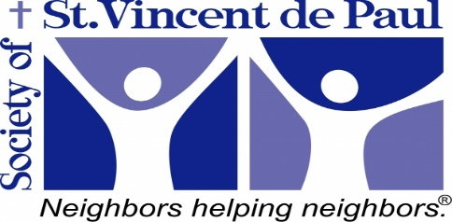
UPDATE: During the last 3 months, the St Elizabeth Seton SVDP has assisted an average of 28 families per month with food and 5 families with rental assistance and PG& E.
One hard working full time employee that was homeless needed the first month's rent and security deposit to get into a studio apt. He will now have shelter and be able to afford his month to month rent.
Another lady was unemployed because of health issues for a year and depleted her savings. She needed help with rent and was able to get back to work.
The other 3 all had hours cut or had work permits expire or lost a job and needed time to find a new job. We prevented one from imminent eviction.
We are able to do this because of your generosity and the "twinning" of other parish conferences.
God bless and guide us in assisting our brothers and sisters!
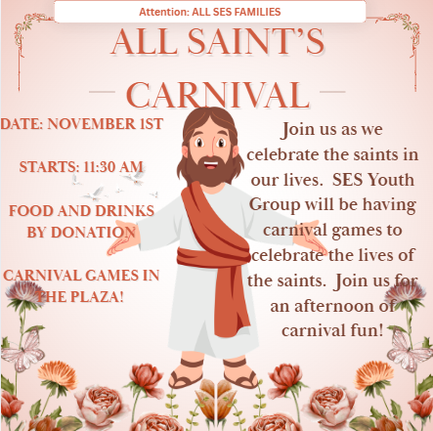
Ministry Schedule October 24th & 25th
4:00pm Mass
Readers: Linda Anderson, Tony Sacramento
EMS: Joanne Bishop, Tony Turegano, Bill Yates
Ushers: Olivia Salazar, Beth Turegano
Greeters: Roxanne Bialkoski, Pat Yates
8:30am Mass
Readers: Scott Crossen, Maria Van Anne
EMS: Larry Biondini, John Buhagiar, Dave Grundman
Ushers: Gus & Liz Chang
Greeters: Larry & Jo Ruminson
10:30am Mass
Readers: Fred Adam, Mary Denson
Ushers: Scott & Milagros Morrical
Greeters: Janet Adam, Sally Shami



The Welcoming Church continues this Wednesday at 6pm in the hall. is a time to: 1 . First of all welcome new or established people to our parish family whether they are baptized or not. 2. Learn about what attracts them to the Lord and the parish. 3. Learn more about their stories and who inspired them in the faith. 4. And to make them feel comfortable. This first stage of the Welcoming Church is to do some inquiring and in November to begin to be drawn closer to the Lord with: Prayer, Scripture Sharing, and Learning the Faith of the Church. In other words: to Know-Go-and-Show the way of the Lord All of us are on a journey to find meaning Last Chance! Please join us.
Congratulations to the McCabe Family on the baptism of their daughter Madeline.
