St. Elizabeth Ann Seton Catholic Church 4595 Snyder Lane Rohnert Park, CA 94928 (707) 585-3708 Website:www.Stelizabethrp.com E-Mail stelizseton@sbcglobal.net Office Hours: Tue.- Fri. 9am - 1pm The Church is open daily 7:30–8:30pm
August 2,2026
18th Sunday in Ordinary Time

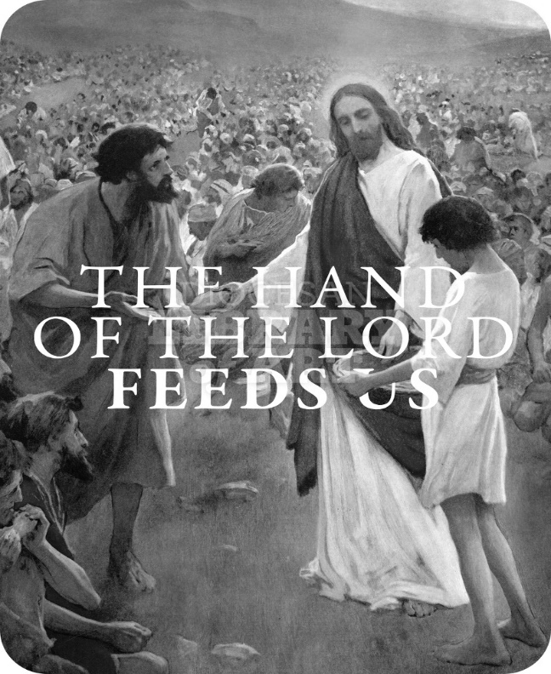

Parish Staff
Pastor: Rev. Thomas Diaz #4 Office Manager: Chris Giacometti: #1
Mass times: #2
Youth Faith Formation: Jennifer Bedoka #3
Executive Board: Tony Madia/Chairperson, Linda Biondini/Vice Chairperson, Katie Chase, Larry Ruminson, Diane Colbrook
Floral Decorations: Cesira Rantissi Heric (707) 338-3959.

Sacraments and Devotions
Reconciliation: Sundays: 9:45-10:15am, Wed. 5:45-6:15pm. (new time), Thu 1-1:30pm.
Marriage: One year notice to the pastor.
Infant Baptism: 1 month notice. The Baptismal Preparation Class today Aug, 2nd is cancelled as no one registered. Participants needed to have registered in the office by Thursday for the class.
Anointing of the Sick: Please call Fr. Tom. Usually, it is celebrated after 10:30 Sunday Mass
The Rosary: ½ hr. before weekday Masses.
Divine Chaplet: Tuesdays after the12:15 Mass
Exposition & Benediction: Thu.12:45-1:45pm.

Mass Schedule and Intentions for the Week
Sat/Aug 1 4pm +Abel Sagon
Sun/Aug 2 8:30am People of the Parish
10:30am +Jimmy Piccetti
Tue/Aug 4 12:15pm +Salud & Joaquinito
Dayanghirang
Wed/Aug 5 5pm +Charlie Couto Lima
Thu/Aug 6 12:15pm +Jordan Ginn
Fri/Aug 7 8:15am +Paul Morales
Sat/Aug 8 4pm +Jeanette Landucci
Sun/Aug 9 8:30am People of the Parish
10:30am +Arturo P. Rico

Events in the Parish
Mon/Aug 3 6:30pm Men’s Club Mtg/Cl
Wed/Aug 5 4:30pm Filipino Ministry Mtg
Thu/Aug 6 5:30pm Filipino Novena/Church
Fri/ Aug 7 4-7pm Rummage Sale
Sat/Aug 8 7-5:30pm Rummage Sale
Sun/Aug 9 9-1 pm Rummage Sale

Stewardship For the month of July
7/5: $4,531, 7/12: $4,512, 7/19: $3,740, 7/26: $5,337, On-line $1,397.25. Average giving: $4,879
Priests Benefit and Welfare $1,615, Church Maintenance $1,500, Next Sunday we have our Mission Appeal by Brother Felix of the Passionist Missionaries

Remembering Last Week’s Homily

- This Sunday invites us to seek God first.
- What is more valuable than God’s love?
- Do you work hard to build up this relationship with God in building up His Kingdom?

Sunday Scripture Readings
Reading I Isaiah 55:1-3 Reading II: Romans 8:35,37-39, Gospel: Matthew 14:13-21

Sunday Reflection
The Innermost Desire Today’s First Reading (Isaiah 55:1-3) is one of the great roots of spirituality for the Biblical tree. It talks about desire. If you are thirsty, come to the water. If you are hungry, come and eat. It is as simple as that.
Some people laugh if I ask them whether they know the hymn "Come to the Water." To them it is like asking whether they have heard the Star Spangled Banner. Since I am the composer of "Come to the Water" (but not of the Star Spangled Banner!), I am humbled.
But of course, it is not "my" hymn, it is ours. The Christian and Catholic community understand Isaiah’s words (the words of the hymn) as naming something very deep within them, a mighty and profound opening within human beings in which they can taste the sweetness of the Lord. I think of huge areas of the world physically without enough food or water, such a scourge upon the earth. You and I can help solve it. But only by feeling the keen hunger within us for God.
Only God can slake our thirst for being loved and giving love, our need for the whole of our life to make sense, our feeling of emptiness at odd times or maybe all the time, our desire for "something more" than our difficult lives can provide. Some of us are simply hoping that there is some reason for hoping at all.
Only God can give out food good enough to satisfy our longing, because only God is the creator and lover of all that is. He is not some being who created the world some time in the distant past and then sat back to let things take their course, however rough that course may be. God creates all things right now, continuing to keep everything in existence right this second. Even one centimeter of a second’s inattention on the part of God and the world would cease.
To the eyes of faith this continuous creation is a beautiful cause for quiet gratitude.
"Come to the Water" says as much: "Why should you spend your life, except for the Lord." The word "spend" here calls to mind spending your wages. But more important, the Gospel for Sunday says how Jesus paid out his own life. It is a special scene. Jesus is grieving for his mentor and friend, John the Baptist. He want to be alone in order to let that grief happen. But instead of solitude, Jesus finds a huge crowd of hungry people, hoping he will feed their souls. His heart is moved by them. He puts aside his own sadness and cures them. He feeds their hunger and slakes their thirst.
In the Gospel reading it is their physical needs he attends to, as a symbol of their deeper hunger. And on Sunday you and I will be fed by his life itself (especially when we hear the readings) and by his very passion, death and resurrection (Eucharistic rite, Communion). We are invited in. Our deepest longing is to be assuaged. We are fed.
"Take this, all of you, and eat it. This is my body."
John Foley, S.J.

Discussion Question: How do I see God’s generosity in my life?

Sunday Family Connection: Talk together about some of the stresses and demands for time and attention that your family members might feel. Acknowledge that we sometimes have to make difficult choices about how to use our time, talents, and treasure. Then read together today's Gospel, Matthew 14:13-21. Notice how much Jesus cared for the crowds, healing the sick even though he wanted to withdraw to a quiet place. Notice how the disciples responded to Jesus' instruction to feed the crowd; they noted their limited supply of food. Jesus blessed this limited supply of food, and it was enough to feed the entire crowd, more than 5,000 people, and there were leftovers! Pray together that Jesus will grant us compassion like his so that we will offer whatever we have to others with compassion and generosity. Pray together today's Psalm, Psalm 145, or the Lord's Prayer.
Please pray for the health intentions of:
Bi Bi Ballesteros, Giselle Ballion, Catherine Delara, Diva & Gaba Delara, Giovanna DeSimone, John Diaz, Marcella Dorado, Maryann Eger, Marcus Esplada, Jim Estrella, Rosita Faltado, Janet Fenstermacher, Kathy & Cedric Fontana, Greyson Goff, Nancy Keegan, Sue Kennedy, Trinidad Legasti, Fatima Manhoso, Judith Miller, Judy Nelson, Joseph Patrick, Mary Piccioni, Vivian Pruett, Emi Jade Przyborowski, Colomba Sebastiani, Linda Sime, Cecilia Tarrant, Diane Thrailkill, Jim Turegano, and Tiffany Valentine, Steve Werle.
To put a name on the list, please call the office

FIRST COMMUNION AND CONFIRMATION REGISTRATION CLOSE AUGUST 30TH

Please use the QR code provided or fill out a packet located in the vestibule. Families can turn in registration forms after Masses or during office hours.
Faith Formation Rummage sale
August 7th, 8th, and 9th!
You still have time to drop off your unwanted treasures to the parish hall this coming week: Monday, August 3rd through Thursday, August 6th from 5pm-8pm.
Do you like to bake? Faith Formation is looking for baked goods to sell at our rummage sale, please drop off baked good starting Thursday, August 6th from 5-8 or during the rummage sale!
CALLING ALL PARENTS, STUDENTS, AND PARISHIONERS WHO WANT TO HELP WITH THE RUMMAGE SALE, PLEASE CHECK OUT OUR SIGNUP: https://www.signupgenius.com/go/10C0D4AA5AF2AA0F9C52-64589570-2026annual
Test 707-888-9672 to find out how you can help!
Thank you for your support!

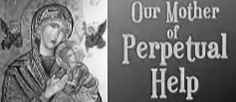
Dear Friends,
You are warmly invited to join us in prayer to Our Lady of Perpetual Help, seeking her loving intercession and guidance the first Wednesday of every month. Together, we lift our hearts in faith, entrusting our needs, hopes, and gratitude to our Blessed Mother, who never ceases to help those who call upon her on Wednesday, August 5th at 4pm in the church. We will gather together for the 5pm Mass. Let us come together as one family in Christ, confident that through Mary’s powers, God’s grace will abundantly flow into our lives. Whether you carry a special intention or simply wish to give thanks, your presence will be a blessing to all.
With Wednesday night Mass we will continue with our monthly meeting on Thursday August 6th at 5:30pm in the hall. The Filipino-American Society of Saint Elizabeth Ann Seton.


Socials
We want to thank the Women’s Guild for hosting the Café on Sunday. It was a great day for treats and fellowship. They received $200.00 in donations but have generously donated it to socials for future church events. Our next Café will be August 23rd hosted by Faith Formation. Please come and join us.

It’s Time Again!!!!
Save the date for the Parish Picnic, September 13th. Check upcoming bulletins for more information


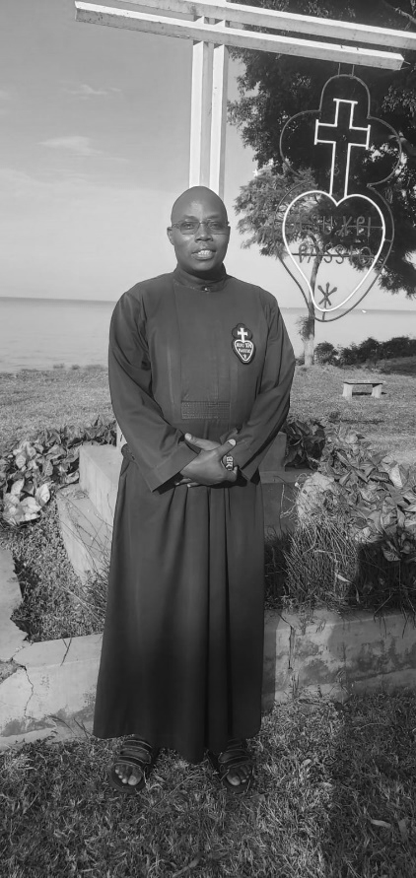
Mission Appeal by Brother Felix on August 8th and 9th.

The Passionist Missionaries goal is to promote the memory of the Passion of Jesus Christ by witnessing and preaching to the sufferings of our time.
Through their projects in Kenya, they are able to evangelize and promote integral human development. Their projects involve programs and activities for alleviating poverty and foster social justice and economic empowerment of the communities they serve. They have 36 seminarians, they run two orphanages with 70 orphans, and they support
poor widows in their rural missions. They organize and preach retreats for both religious and lay Faithful. Your generous support will help them to continue in their mission affecting a positive change in people’s daily lives and the hope for a better tomorrow.
Visit www.Passionistskenya.org
Coming in October
Interested in the Roman Catholic Faith?


The Welcoming Church is a journey through different spiritual phases of increasing maturity and faith by which one prepares to commit oneself to Jesus Christ and His Church. Officially the title for this process of coming to know the Lords through the Roman Catholic Church is called the Order of Christian Initiation of Adults (OCIA). We call it here at St Elizabeth Ann Seton Parish in Rohnert Park “The Welcoming Church.” These sessions will be open to all who live in the parish boundaries.
- Who is the Welcoming Church for: Any unbaptized person who seeks to follow Christ in his Church as preparation for Christian discipleship through baptism, confirmation, and the Eucharist.
- Anyone baptized from another Christian community seeking to be a Roman Catholic through preparation for Confirmation and Holy Communion.
- Any baptized Catholic who wishes to be confirmed and possibly celebrate First Communion.
- Any baptized Catholic who seeks to increase his understanding and faith in Jesus Christ.
These sessions will begin on Wed. Oct 13th from 6:00-7:15 pm. Registration and more info later. No commitment is needed to joining the Church until later in the season. Just check things out at this time with an open heart.

Social Justice Backpack Drive Thanks to the generosity of our parishioners, we have exceeded the number of backpacks we hoped to collect for the school children. Therefore, the backpack drive has ended earlier than expected. However, if you have already purchased backpacks to be donated you may still bring them to the vestibule and we will see that they are given to a shelter where needed. May God bless all of you for your kindness and send you many blessings.
Pastor’s Corner
The office personnel have been phoning parishioners to see if they want the collection envelopes from the new company or if they want the envelopes we will be putting out in Oct. The problem is that many of you have cancelled your landlines and have gone to a cell phone and we do not have your phone number. Please phone the office if you have not told us about your phone number change.
A list of all parishioners who will be getting the Our Sunday Visitor envelopes with your number will be published next week, along with those who have a number and want the envelopes we will be providing every week. The new list must be sent to the company by Aug 12th for October delivery.
The Crying Room: Does anyone know what happened to the children’s table in the room. If you are using the ‘Crying Room” please clean up afterwards. Please no food or drink is to be in the room, unless you clean up afterwards.
Does anyone want to donate fresh cut flowers for the sanctuary. Please give Cesira a call. Her name and phone number are on the cover of the bulletin.

Pope Leo and Vatican News

Technology must serve truth and the common good. Pope Leo XIV encourages that, in “the face of the new opportunities offered by technological development, knows how to safeguard the dignity of the human person." By Giovanni Zavatta
Pope Leo XIV has encouraged communicators to ensure that every technological tool is placed "at the service of truth and the common good," as the Church reflects on the opportunities and challenges presented by artificial intelligence.
His message, signed by Cardinal Secretary of State Pietro Parolin, was sent to participants in the Seventh International Seminar on Church Communication, taking place on 27-28 July at the Pontifical Catholic University of Chile in Santiago.
The seminar, entitled The Challenges of Artificial Intelligence, has brought together communicators, pastoral workers, academics and Church representatives from across Latin America and the Caribbean to reflect on the ethical, cultural and religious implications of artificial intelligence in light of Pope Leo XIV's Encyclical MAGNIFICA HUMANITAS Wisdom and responsibility in the age of AI
Addressing Archbishop René Osvaldo Rebolledo Salinas, President of the Chilean Bishops' Conference, the Pope expresses the hope that participants will promote "a communication that, in the face of the new opportunities offered by technological development, knows how to safeguard the dignity of the human person and place every tool at the service of truth and the common good."
Pope Leo also entrusts the seminar to the guidance of the Holy Spirit, praying that its participants may address the challenges posed by artificial intelligence "with wisdom and responsibility, so that ecclesial communication may foster encounter among people and contribute to the proclamation of the Gospel."
Opening the seminar, Cardinal Fernando Natalio Chomalí Garib, Archbishop of Santiago de Chile, reflected on the impact of social media, describing them as "truly human" spaces because they reflect emotions, relationships and conflicts.
"Everything that happens to us also happens there," he said, proposing four essential criteria for communication: truth, goodness, beauty and usefulness.
The Cardinal highlighted that MAGNIFICA HUMANITAS, dedicated to safeguarding the human person in the age of artificial intelligence, should not be read solely from a technological perspective.
"Today there is much discussion about artificial intelligence," he noted, "but this Encyclical speaks above all about human dignity and truth."
Building Jerusalem, not Babel
Cardinal Chomalí said communication rooted in those principles can strengthen community life in an increasingly individualistic society.
"We will promote dialogue, we will promote fraternity; in the end, we will build Jerusalem, not Babel," he said.
The same themes were echoed in the homily he delivered during the Eucharistic celebration that followed. Describing MAGNIFICA HUMANITAS as a "Christological" Encyclical, he called for communication marked by discernment and expressed the hope that artificial intelligence would always remain at the service of human dignity.
A shared journey for the Church
"The inviolable dignity of the human person must constitute the principle, the criterion and the ultimate goal of both technological development and scientific progress," he said.

Ministry Schedule August 8th & 9th
4pm Mass
Readers: Evelyn Estrella, Tony Sacramento
EMS: Jovita Bishop, Joanne Bishop, Victoria Gregorio
Ushers: Olivia Salazar, Beth Turegano
Greeters: Ron & Debra Ciarasso
8:30am Mass
Readers: Dolores Sanchez, Maureen Sheridan Scott
EMS: Diane Cook, Dave Grundman, Mary Thayer
Ushers: Remie Alinas, Barry Goff
Greeters: Alan & Caroline Kalaw
10:30am Mass
Readers: Scott Crossen, Nora John
EMS: Lorraine Datu, Giovanna Desimone, Nora John
Ushers: Giovanna Desimone, Milagros Morrical
Greeters: Lorraine Datu, Sally Shami


Ministers for your dedication!

