St. Elizabeth Ann Seton Catholic Church 4595 Snyder Lane Rohnert Park, CA 94928 (707) 585-3708 Website:www.Stelizabethrp.com E-Mail stelizseton@sbcglobal.net Office Hours: Tue.- Fri. 9am -1pm The Church is open daily 7:30–8:30pm
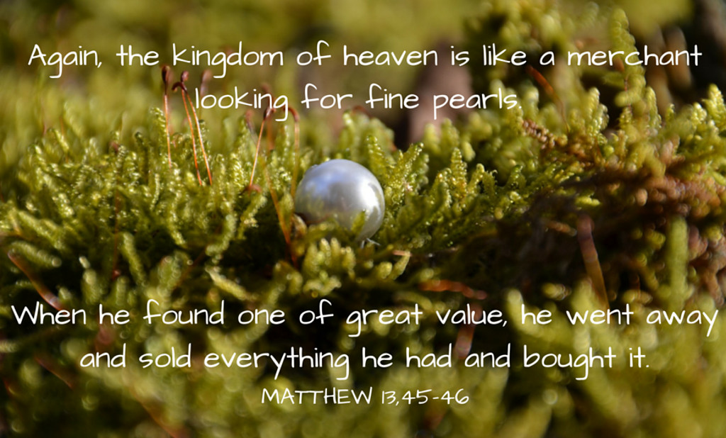
July 26, 2026, 17th Sunday in Ordinary Time
Parish Staff
Pastor: Rev. Thomas Diaz #4 Office Manager: Chris Giacometti: #1
Mass times: #2

Youth Faith Formation: Jennifer Bedoka #3
Executive Board: Tony Madia/Chairperson, Linda Biondini/Vice Chairperson, Katie Chase, Larry Ruminson, Diane Colbrook
Floral Decorations: Cesira Rantissi Heric
Sacraments and Devotions
Reconciliation: Sundays: 9:45-10:15am, Wed. 5:45-6:15pm.(new time) Thu 1-1:30pm.
Marriage: One year notice to the pastor.
Infant Baptism: 1 month notice. The next preparation session will be on August 2nd 12-2pm.
Anointing of the Sick: Please call Fr. Tom. Usually, it is celebrated after 10:30 Sunday Mass
The Rosary: ½ hr. before weekday Masses.
Divine Chaplet: Tuesdays after the12:15 Mass
Exposition & Benediction: Thu.12:15-1:45pm.

Mass Schedule and Intentions for the Week
Sat/July 25 4pm Ints.of Charles McCollum
Sun/July 26 8:30am +Carlos Ruiz
10:30am People of the Parish
Tue/July 28 12:15pm +Bill Herbert
Wed/July 29 5pm +Jimmy Piccetti
Thu/July 30 12:15pm +Lanny Marlatt
Fri/July 31 8:15am +Maria Luisa Recaro
Sat/Aug 1 4pm +Abel Sagon
Sun/Aug 2 8:30am People of the Parish
10:30am +Jimmy Piccetti

Events in the Parish
Sun/July 26 9:30am-12 SEAS Café SVDP Mtg
Tue/July 28 1 pm Finance Mtg/Cl
Wed/July 29 Noon Potluck Luncheon/Hall

Stewardship for July 19th
Plate $3,740 The second collection for Priests Benefit and Welfare $1,500. Thank you but Ouch! We need an average of $5,000 a week for the 1st Collection.

Remembering Last Week’s Homily
- We have the good seeds of Jesus growing in our hearts
- We also have weed seeds planted by the devil in our hearts (sin),
- Jesus has patience with us in judging us, so we have time to change
- Let us give others that same chance and not judge their bad seeds.

Sunday Scripture Readings
Reading I: Wisdom 12:13, 16-19, Reading II: Romans 8:26-27, Gospel: Matthew 11:25

Sunday Reflection


Layers of Wisdom Look at the many different depths and types of wisdom in the world, and thus in this Sunday’s Mass. Here is an everyday example. I remember a cartoon in the New Yorker magazine years ago that etched itself in my mind. An old man is sitting on his front porch while a very beautiful woman walks by on the sidewalk. His mouth is hanging open. His old wife is at the door, with the screen pushed open just far enough to take in this scene. She says to him, “Well whistle, you damn fool!” I suppose I had expected her to load guilt on the leering old man in his act of leering. Instead, Booth gave us what are really just words of everyday common sense. “Don’t just sit there: at least do what every other heterosexual male in the world would do.” So. Wisdom comes in many flavors, and there is a kind of common, real acumen in the old lady’s words. Now, let us examine Sunday’s readings for different types of wisdom. In the Gospel, Jesus uses the common sense kind. He says, if you went out into a field and saw a suspicious mound of earth, and you happened to dig it up, and you found there a hidden treasure—as much gold as you could ever want—would you immediately go and tell everyone about it? Of course not. It is like “Well whistle, you damn fool!” Common sense says you would re-bury the treasure, disguising it perfectly, and then go sell all your property and come buy the field. Now the treasure is yours. “Look at what I found on my new property!” It is an excellent example. It makes sense. Well then, Jesus asks, wouldn’t you do as much for the kingdom of heaven? He has suddenly deepened the wisdom! And in the First Reading, Solomon uses another flavor of wisdom. He asks not for selfish gifts, but for an understanding heart so that he can rule God’s people. This request moves God. He gives Solomon great practical wisdom in order that he might succeed as King. And other gifts as well. Perhaps the deepest wisdom this Sunday is in the Second Reading. You and I have undoubtedly quoted these words, not remembering where they came from, “All things work for the good [of] those who love God.” The older I get, the more true this seems. Even when darkness and loss become our daily bread, still the love of God labors incessantly to bring out greater forgiveness, larger love, more acceptance of life and love, even within pain. This is the wisest understanding that can be. Sunday at Mass we can pay attention to any of these varieties of wisdom. The important thing is not to just sit there and gape, but to do what every other human being in the world would do if given a glimpse into the kingdom. Listen to God’s love, you sleepy head. John Foley, SJ. Discussion Question: Are you shrewd about recognizing the “treasure” or the kingdom of God in your life?
Sunday Family Connection: We pray that our family values reflect our pursuit of the kingdom of heaven. As Jesus’ disciples, we place everything we value in the service of the pursuit of the Kingdom of God. As you gather as a family, talk about what your family values. Make a list together of those things that your family considers most important, such as family, friends, faith, trust, and love. Place this list before you as you read today’s Gospel in its shorter form, Matthew 13:44-46. In these parables, Jesus teaches us that it is worth giving up even valuable things in order to possess the kingdom of heaven. Look at the list your family made and talk about how these things are important to the kingdom of heaven. What has your family given up to make these values important in your life? As Jesus’ disciples, we place everything we value in the service of the pursuit of the Kingdom of God. Pray together for God’s kingdom by praying the Lord’s Prayer.

Please pray for the health intentions of:
Bi Bi Ballesteros, Giselle Ballion, Catherine Delara, Diva & Gaba Delara, Giovanna DeSimone, John Diaz, Marcella Dorado, Maryann Eger, Marcus Esplada, Jim Estrella, Rosita Faltado, Janet Fenstermacher, Kathy & Cedric Fontana, Greyson Goff, Nancy Keegan, Sue Kennedy, Trinidad Legasti, Fatima Manhoso, Judy Nelson, Joseph Patrick, Mary Piccioni, Vivian Pruett, Emi Jade Przyborowski, Linda Sime, Cecilia Tarrant, Diane Thrailkill, Jim Turegano, and Tiffany Valentine.
Please pray for the soul of Patricia Sack. Keep her family in your prayers.
To put a name on the list, please call the office.

Youth Faith Formation
FIRST COMMUNION AND CONFIRMATION REGISTRATION CLOSES AUGUST 30TH

Please use the QR code provided or fill out a packet located in the vestibule. Families can turn in registration forms when you drop off your rummage sale items after Masses.
Faith Formation Rummage Sale
August 7th, 8th, and 9th!
Donations may be dropped off in the hall (Saturdays 5pm to 7 pm and Sundays 8 am-11:30 am).
Faith Formation will be accepting donations of CLEAN, WEARABLE AND STAIN FREE, USABLE, and FUNCTIONAL HOUSEHOLD ITEMS. Your unwanted items can be treasures to others: housewares, all clothing, purses, sporting goods, toys, cd’s, records, collectibles, shoes, pets, holiday items, and more can be dropped off. We will donation to other non-profits after with items that were not sold, if possible.
THANK YOU FOR ALL THE DONATIONS WE HAVE RECEIVED SO FAR…
Please email sesreled@gmail.com or text 707-888-9672 photos of larger items.
CALLING ALL PARENTS, STUDENTS, AND PARISHIONERS WHO WANT TO HELP WITH THE RUMMAGE SALE, PLEASE CHECK OUT OUR SIGNUP: https://www.signupgenius.com/go/10C0D4AA5AF2AA0F9C52-64589570-2026annual
Thank you for your support!
This past week our parish hosted a Catechesis of the Good Shepherd for catechists who want to share the joy of prayer and the love of our Good Shepherd for ages 0-3. Take time to learn about the youngest children
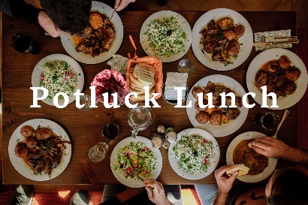
All are welcome! Wednesday at noon in the hall. All are welcome! Bring something to share.

Please return your missalettes to their proper place, the bookshelf, in the vestibule.

Pastor’s Corner
It is interesting. After I talked about the collection
envelopes last week and requesting people use them or change the way we will be doing things in Oct. In Oct. you can keep your number with the new monthly envelopes. Since many do not use the envelopes regularly you will be able to pick up an envelope in the vestibule and fill out your number and name, if you did not want the company envelopes. I am sorry for any confusion, but when I asked if there were any questions. No one said anything. Do not be shy!
The company sent the late collection envelopes last week and they had errors for this month through Sept. (one reason we are dropping the company.
So here is a master schedule

OUR RIGHT SCHEDULE
1. Jul 18/19 16th Sunday of Ordinary Time 2nd Collection Priests Benefits and Welfare
2nd Collection Mission Appeal NO
2. Jul 25/26 17th Sunday of Ordinary Time
3. Aug 1/2 18th Sunday of Ordinary Time
4. Aug 8/9 19th Sunday of Ordinary Time
2nd Collection Mission Appeal for Kenya
2nd Collection Building Maintenance NO
5. Aug 15 The Assumption NO! Not a Holy Day of Obligation this year.
6. Aug 15/16 20th Sunday in Ordinary Time
2nd Collection Building Maintenance
7. Aug 22/23 21st Sunday of Ordinary Time
8. Aug 29/30 22nd Sunday of Ordinary Time
9. Sep 5/6 23rd Sunday of Ordinary Time
10. Sep 12/13 24th Sunday of ordinary Time
2nd Collection Building Maintenance
11. Sep 19/20 25th Sunday in Ordinary Time
2nd Collection Seminarian Formation
12. Sep 26/27 26th Sunday of Ordinary Time
NEW ENVELOPE COMPANY IN OCT.

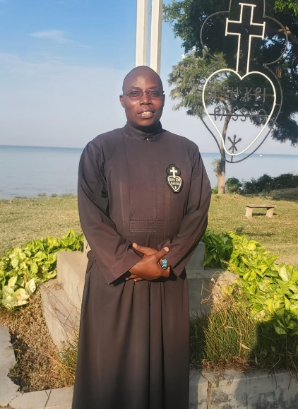
Mission Appeal by Brother Felix on August 8th and 9th.
The Passionist
Missionaries goal is to
promote the memory of the Passion of Jesus Christ
by witnessing and preaching
to the sufferings of
our time, through their actions and prayers to lifegiving
projects in Kenya.
More information on this Mission Appeal next weekend.

PASTOR’S CORNER PART II
Look into your garages and closets for articles for the Youth Faith Formation Rummage Sale in a few weeks.
I want to thank Linda Biondini who has led the Women’s Guild for the last few years as Lucy Madia and Paula Moore will lead the Women’s Guild as co-chairpersons. Linda has been such a devoted leader and has raised the identity of the Women’s Guild over the years. May God bless you Linda!
I thank the Men’s Club for putting on another delicious breakfast for the parish.
Phoning is still being made in the evenings to organize our church envelopes with a new provider.
A reminder that Mass on Wednesdays is at 5pm. The time change was to bring families and individuals together at an easier time to celebrate the Mass. Would it not be great, if more people went to a daily Mass not out of an obligation but out of love of God.

The Filipino American Ministry enjoyed sharing Filipino Friendship Day on July 12th. A special thank you to Lorraine Datu for her creative dishes and flyers, to Luisa Wagy our amazing treasurer, and to our fellow members who tirelessly cooked, danced, and decorated to make this event such a success. Thank you to the men’s club for helping with set-up. We raised a total of $5,530.39. Half will be going to the parish renovation fund and congratulations to Fr. Tom for winning the 50/50 raffle and donating some of the profits back.

Scrip Update
SES Scrip program was started in Oct of 1990 and with the support of the parishioners we have raised over $151,000 dollars for our parish. Thank you to all our volunteers that help with Scrip and the participating parishioners that purchase Scrip. This last fiscal year, July 2025 through June 2026, this program has raised $1,999.70 with a small percentage of participants. Scrip gift cards are available for purchase in the office and after all the weekend masses. We carry the following scrip gift cards:
Grocery Stores:
Raley’s, Safeway and Walmart
Restaurants / Food:
Applebee’s, Chili’s, Cold Stone, Domino’s, Olive Garden, See’s Candy, Starbucks
Over Store / Merchants:
Amazon, Home Depot, Target, Wal-Mart, Tip-Top Cleaners (limited supply)
Gas Stations:
Arco Gas (limited supply), Shell Gas
All profits from our scrip program benefit
St. Elizabeth Seton landscaping around our parish.
The more we participate the more we can grow.
Thank you for your support.


Social Justice Ministry Your Social Justice Ministry mourns the death of Lindsey Graham, a long time champion for the protection of the unborn child, and we pray that Pro-Life groups continue the efforts that he supported. Your Social Justice Ministry, on behalf of Catholic Charities, is placing a request for BACK TO SCHOOL BACKPACKS ONLY. We will be collecting new, and unused backpacks suitable for school books and supplies to elementary through high school students, and will be distributed to the youth in their shelters. This drive will start July 18th and run through August 9th. There will be a large basket in the vestibule for drop offs. Our Parish has always proven to be a generous Parish. God bless you!
Baptismal Preparation Class for Parents
Sunday Aug 2nd in the Center Classroom
Please register for this session, with a $25 registration fee and by phoning the office by Thursday noon. The fee will be returned if you show up. Too often people register but do not show and so the sessions are cancelled.

Special Liturgical Date this Week
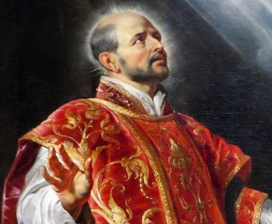
July 31st, St Ignatius of Loyola
Prayer to St Ignatius
Receive, O Lord, all my liberty. Take my memory, my understanding, and my entire will, and I surrender it wholly to be governed by Your will. I am rich enough and ask for nothing more. All that I have and call my own, You have given it all to me. To You, Lord, I return it. Everything is Yours; do with it what You will. Give me only Your love and Your grace. That is enough for me."

Early Life: St. Ignatius of Loyola was born in 1491 in the Basque region of Spain. Originally a soldier, he was severely wounded in the Battle of Pamplona in 1521. During his recovery, he devoted himself to reading religious texts, which inspired a profound spiritual
conversion and a commitment to a life of prayer andservice to God.
Foundation of the Jesuits`In 1534, Ignatius and a small group of companions took vows of poverty andchastity, planning to travelto Jerusalem. After delays due to political and religious circumstances, they were approved by the Pope in 1540 to form the Society of Jesus. The Jesuits became a key force in the Catholic Counter-Reformation, emphasizing missionary education, and intellectual engagement with contemporary issues.
Spiritual Exercises St. Ignatius is renowned for his work "Spiritual Exercises", a collection of meditations, prayers, and contemplative practices designed to deepen one’s relationship with God and discern life choices. These exercises remain central to Jesuit spirituality and are widely used in retreats and personal devotion.
For more on his spiritual exercises go to:
Imaginative Prayer- IgnatianSpirituality.com This is so special in making the Gospels come alive for individuals and your pastor recommends it.
Imaginative Prayer- IgnatianSpirituality.com This is so special in making the Gospels come alive for individuals and your pastor recommends it.

Pope: Do not forget those most in need during the summer By Isabella H. de Carvalho
Pope Leo XIV encourages Christians not to forget about the sick, the elderly and those who are suffering during the summer season.
How to nurture our spirituality in a frenetic world.
The Pope’s response: live out the Gospel of peace and mercy
The Pope’s response firstly remembers “those who cannot even enjoy a brief period of rest because they are crushed by burdens of every kind.”
“Let us think of the sick, of those who have lost hope in life, of those overwhelmed by the pain of losing loved ones, of the victims of war, hatred, terrorism, and violence, of those persecuted for their faith and for justice, of prisoners, of those who have lost their jobs or their homes, and of migrants who are not welcomed with humanity,” the Pope emphasizes.
He notes how holidays should be for everyone a time of respite from work and worries in order to experience genuine friendship and company, as a foretaste of the communion of the Kingdom of God.
In order to strengthen one’s faith, he thus calls all Christians to “make use also of the summer to live out the Gospel of peace and mercy.”
“To families, parents and children, the young and the elderly alike—I wish that this summer may be an opportunity for fruitful social and religious experiences, and for deepening their mission in the Church and in society,” he insisted.
He added that he hoped the sick would not lack the closeness of their relatives and volunteers and urged families to not leave their elderly members alone.
Ministry Schedule Aug 1st & 2nd
4:00pm Mass
Readers: Linda Anderson, Linda Biondini
EMS: Luisa Bustillos, Janice Dyer, Tony Madia
Ushers: Dianne Foppoli, Tony Turegano
Greeters: Ron & Debra Ciarasso
8:30am Mass
Readers: Teresa Fonseca, Maureen Sherida Scott
EMS: Remie Alinas, Diane Cook, Patty Ramos
Ushers: Barry Goff, Mary Thayer
Greeters: Giovanna Desimone, Agustine Gonzalez
10:30am Mass
Readers: Mary Denson, Milagros Morrical
EMS: Giovanna Desimone, Danne Foppoli, Milagros Morrical
Ushers: Lorraine Datu, Scott Morrical
Greeters: Giovanna Desimone, Agustine Gonzalez

