St. Elizabeth Ann Seton Catholic Church 4595 Snyder Lane Rohnert Park, CA 94928 (707) 585-3708, E-Mail stelizseton@sbcglobal.net Website:www.Stelizabethrp.com Office Hours: Tue.- Fri. 9am - 1pm The Church is open daily from 7:30–8:30pm. July 19, 2026
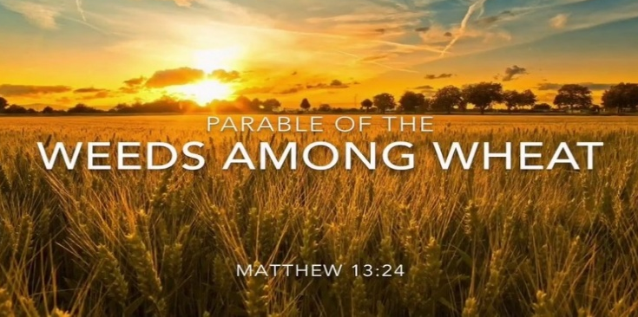
16th Sunday in Ordinary Time

Parish Staff
Pastor: Rev Thomas K. Diaz #4
Office Manager: Chris Giacometti #1
Mass Times: #2
Youth Faith Formation: Jennifer Bedoka #3
Executive Board: Tony Madia/Chairperson,
Linda Biondini/Vice Chairperson, Katie Chase,
Larry Ruminson, Diane Colbrook
Floral Decorations: Cesira Rantissi Heric (707)338-3959
Sacraments and Devotions
Reconciliation: Sundays: 9:45-10:15am, Thu.1-1:30
Marriage: One year notice to the pastor.
Infant Baptism: 1 month notice. The next Baptismal Prep Class TBA
Anointing of the Sick: Is celebrated after the 10:30am Sunday Mass and by appointment.
The Rosary: ½ hr. before weekday Masses.
Divine Chaplet: Tuesdays after the12:15 Mass
Exposition & Benediction: Thu.12:45pm-1:45pm.

Mass Schedule and Intentions for the Week
Sat/July 18 4pm Ints of Sandra Undorte
Sun/July 19 8:30am +Bob King
10:30am People of the Parish
Tue/July 21 12:15pm +Jose Luis Araiza
Wed/July 22 5pm +Claire Ribiero
Thu/July 23 12:15pm Ints of Mila Morrical
Fri/July 24 8:15am +Jack McCormick
Sat/July 25 4pm Ints of Charles McCollum
Sun/July 26 8:30am +Carlos Ruiz
10:30am People of the Parish

Events in the Parish
Sun/July 19 Breakfast after the Masses
11:30am Hispanic Ministry Mtg/Cl
Noon EM Mtg for Shut-ins/Cl
Thu/July 23 6pm pastoral Council Mtg./Hall
Sun/July 26 9:30am SVDP Mtg/Hall
SEAS Café after Masses
Stewardship For July 12th: Plate $4,512 The 2nd collection for Building Maintenance $1,390. The 2nd collection today is for our Retired Priests Welfare and Benefits.

Looking back at last Sunday’s Homily

- The Father is the seed, Jesus is the sower, and we are the soil
- What kind of soil are we?
- What does it mean to have God take deep root?

Sunday Scripture Readings
Reading I: Wisdom 12:13,16-19 Reading II: Romans 8:26-27 Gospel: Mathew 13:24-30, 36-43.

Sunday Reflection Pulling Out Weeds So, if you or I have sinned, then we have weeds growing up along with the good that is in us. Would we like to be uprooted? No. Instead, God lets us develop, without destruction, steadily forgiving our weeds. If so, maybe you could look at the point of Sunday’s Gospel. When someone hurts us with their wrongs (or vise versa), maybe we can avoid rushing up to them to rip out weeds. Mixed with all the crab grass there are lovely flowers, and God loves very much all that they are. Look, the crimes we commit don’t really agree totally with our inner self! None of the weeds growing up in us are wonderful, but they are only a part of who we are. Our urge to steal, to impress others falsely, to judge, to get what we want no matter what, to be lazy, petulant, or … (please fill in the kind of wrong you yourself are drawn to). These are not a full description of who we are. Let us do our best to tolerate the thorns and keep our hands off them. Our own weeds are treated with care. What if Jesus had said from the cross, “Father, damn them to hell forever because of what they are doing to me”? He said instead “forgive them, they know not what they do.” He knew there was good wheat in them, even alongside terrible weeds. Forgiveness is letting go of an angering injury and giving God a chance to love. Wouldn’t you like to be loved and forgiven this way? John Kavanaugh, S.J.
Discussion Question:
Care, justice, mercy and leniency. What would world be like if all leaders had possessed these qualities?

Please pray for the health intentions of:
Bi Bi Ballesteros, Giselle Ballion, Catherine Delara, Diva & Gaba Delara, Giovanna DeSimone, John Diaz, Marcella Dorado, Maryann Eger, Marcus Esplada, Jim Estrella, Rosita Faltado, Janet Fenstermacher, Kathy & Cedric Fontana, Greyson Goff, Nancy Keegan, Sue Kennedy, Trinidad Legasti, Fatima Manhoso, Judy Nelson, Joseph Patrick, Mary Piccioni, Vivian Pruett, Emi Jade Przyborowski, Linda Sime, Cecilia Tarrant, Diane Thrailkill, Jim Turegano, and Tiffany Valentine. To put a name on the list, please call the office.


MEN’S CLUB BREAKFAST TODAY, Sunday, July 19th after the Masses. Come and join us as it is free and the company is great!

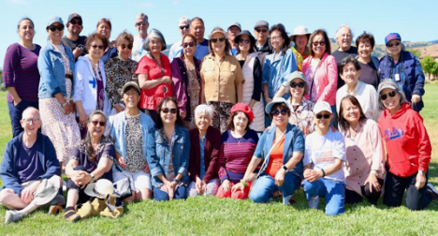
The Filipino American Society would like to thank all those who participated at the Filipino American Friendship Day last week, and to all those who put a lot of work into it. Blessings to you!

FIRST COMMUNION AND CONFIRMATION CLASSES ARE OPEN!


Please use the QR code provided or fill out a packet located in the vestibule. Families can turn in registration forms after Masses.
THANK YOU FOR ALL THE DONATIONS WE HAVE RECEIVED SO FAR…
Faith Formation Rummage Sale August 7th, 8th, and 9th!
Donations may be dropped off at the hall (Saturdays 5pm - 7 pm and Sundays 8 am - 11:30 am. Please make arrangements for other times.
Faith Formation will be accepting donations of CLEAN, WEARABLE AND STAIN FREE, USABLE, and FUNCTIONAL HOUSEHOLD ITEMS. Your unwanted items can be treasures to others: housewares, all clothing, purses, sporting goods, toys, cd’s, records, collectibles, shoes, pets, holiday items, and more can be dropped off. We will donation to other non-profits after with items that were not sold, if possible.
Please email sesreled@gmail.com or text 707-888-9672 photos of larger items.
CALLING ALL PARENTS, STUDENTS, AND PARISHONERS WHO WANT TO HELP WITH THE RUMMAGE SALE, PLEASE CHECK OUT OUR SIGNUP: https://www.signupgenius.com/go/10C0D4AA5AF2AA0F9C52-64589570-2026annual
Thank you for your support!


Social Justice Ministry Your Social Justice Ministry, on behalf of Catholic Charities, is placing a request for BACK TO SCHOOL BACKPACKS. We will be collecting new, unused backpacks suitable for school books and supplies to elementary through high school, and will be distributed to the youth in their shelters. This drive will start July 18th and run through August 9th. There will be a large basket in the vestibule for drop offs.
Pastors Corner I want to thank Tony Turegano, Sally Shami, and Richard Bohan for working on the grounds and John Buhagiar and Dave Grundman for working on the fountain repairs.

PASTOR’S PLEASE - READ PART 2
Why do we wrap Birthday and Christmas presents?
We do it to make things more special. Why should people use church envelopes? To make their giving more special with their financial gift, like a prayer to God, rather than making it a business transaction. The envelope reminds us to look at our lives during the week and see how God has blessed us and to return a gift to the Lord to take care of God’s people.
We are redoing our Sunday Collection Envelopes with a new company beginning in Oct.
Out of 580 families in the parish, we have 294 who are signed-up for them but 109 do not use them and 29 give under $100 during the year in our records. If you wanted them, the 138 families, why do you not use them? And there are many who donate once a month and use only one envelope and maybe the 2nd collection envelopes for the 2nd and 3rd Sundays. The company cannot send out custom envelopes to people who want envelopes once or twice a month but for every week.
The new company will let you keep your number
So, to help us straighten things out. Miss Dulcenea Flores, a parish office worker, will be phoning all those who have signed up for envelopes and will be asking a few questions.
- Do you want to continue getting envelopes?
- Or do you want to put your name, number and Sunday date on an envelope that will be provided beginning in Oct?
Everyone will be mailed a schedule of our 2nd collections and holy Days of Obligation in Oct.
So, use them or lose them as the saying goes but keep your number. One’s total giving should be at least $300 a year. Cell phone usage, cable, and junk food should be less than what you give.
Also, many people take off on weekends and do not give on those Sundays. If you are buying a house and were gone for a month you still need to pay your mortgage. We will be going over “giving online” when we start with the new company, so you do not forget to thank God with your giving when away.
Ministry Schedule: July 25th & 26th
4:00pm Mass
Readers: Tony Madia, Liz Ritchie
EMS: Evelyn Estrella, Linda Mish, Bill Yates
Ushers: Dianne Foppoli, Beth Turegano
Greeters: Olivia Salazar, Pat Yates
8:30am Mass
Readers: Dolores Sanchez, Maria Van Anne
EMS: Remie Alinas, Patty Ramos, Mary Thayer
Ushers: Gus & Liz Chang
Greeters: Alan & Caroline Kalaw
10:30am Mass
Readers: Linda Biondini, Mary Denson
EMS: Lorraine Datu, Victoria Gregorio, Nora John
Ushers: Scott Crossen( sub req) Sally Shami
Greeters: Fred & Janet Adam

