St. Elizabeth Ann Seton Catholic Church 4595 Snyder Lane Rohnert Park, CA 94928 (707) 585-3708,Website:www.Stelizabethrp.com E-Mail stelizseton@sbcglobal.net The Church is open daily from 7:30am–8pm . August 30, 2026 22nd Sunday of Ordinary Time
 Jesus says to Peter,” Get behind me Satan”.
Parish Staff
Pastor: Rev. Thomas Diaz #4 Office Manager: Chris Giacometti: #1
Mass times: #2
Youth Faith Formation: Jennifer Bedoka #3
Executive Board: Tony Madia/Chairperson, Linda Biondini/Vice Chairperson, Katie Chase, Larry Ruminson, Diane Colbrook
Floral Decorations: Cesira Rantissi Heric
(707)338-3959
Sacraments and Devotions
Reconciliation: Sundays: 9:45-10:15am, Thu 1-1:30pm.
Marriage: One year notice to the pastor.
Infant Baptism: 1 month notice. The next preparation session is on Sept.20th noon-2pm.
You must register in the office for the class.
Anointing of the Sick: Please call Fr. Tom .for an appointment at the church or in your home Usually, it is celebrated after 10:30 Sunday Mass.
The Rosary: ½ hr. before weekday Masses.
Divine Chaplet: Tuesdays after the12:15 Mass
Exposition & Benediction: Thu.12:45-1:45pm. Adult Initiation Sessions: Starting Oct 14th at 6pm.

Mass Schedule and Intentions for the Week
Sat/Aug 29 4pm +Sam Aggio
Sun/Aug 30 8:30am People of the Parish
10:30am +Lourdez & Nelson Galvez
Tue/Sep 1 12:15pm Ints. Maria Sharts
Wed/Sep 2 8:15am +Dorothy Aggio
Thu/Sep 3 12:15pm Ints. of Mila Morrical
Fri/Sep 4 8:15am +Pacifico Gorospe
Sat/Sep 5 4pm +George Turegano
Sun/Sep 6 8:30am +Marie Aggio
10:30am People of the Parish

Parish Events This Week Fri/Sep 4 4:30pm Social Justice Mtg/Cl
Last Sunday’s Homily Highlights
- Who is Jesus to me
- How can I grow in my understanding of who Jesus is?
- What does Jesus mean to me personally?
- Do I try to control my life instead of trusting in God?
- What steps can I take to strengthen my relationship with Jesus?
- The more I know Jesus in my heart, the more I need to serve others?
- In what ways can I serve others?

Sunday Scriptural Readings
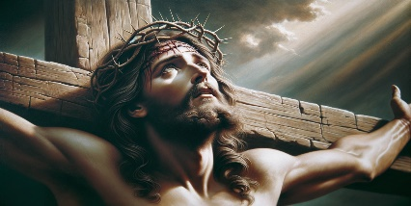
Reading I-Jeremiah 20:7-9, Reading II-St. Paul to the Romans 12:1-2, Gospel-Matthew 16:21-27 Sunday Reflection This week, Peter is in for a big surprise. In last week’s Gospel Jesus retired the name “Simon” and replaced it with the name Peter. And so I say to you, you are Peter and upon this rock I will build my church, and the gates of the netherworld shall not prevail against it We heard that, at root, the name Peter meant “rock.” Simon is to be a “Rock,” the foundation of the church. Surprise, surprise, the name Jesus gives Peter this week has a very different flavor: he calls him “Satan”. If this name were to stick, Peter would be the leader of the very “netherworld” which Jesus promised could not prevail against the church. What has happened? First, it is quite clear that Jesus’ emotional state has changed. He is obviously dreading the suffering and death he will soon have to face. His rebuke to Peter is so sharp, so instant, so contradictory, that its emotional roots are showing. He knows what a terrible toll human misery and affliction will take on him. He snaps at Peter and even resorts to name-calling. Second, Jesus had been gradually schooling the disciples about who he really is. Not just a great teacher, or good friend, or magnetic preacher, but the complete revelation of divine love. They had achieved their first high mark last week when Peter said, “You are the Christ, the Son of the living God.” (Gospel, 21 Ord A 20) Up until now he had not spoken a word to them about the crucifixion. At this stage, they should be able to begin to understand what it means for Jesus to be the Christ. Shouldn’t they? So, this week he shows the real meaning of Christly love: for the good of the world, he must suffer greatly under the elders, chief priests and scribes, and be killed, and on the third day be raised. Do the Apostles get it? No. The Gospel reports that Peter “rebukes” Jesus. Something like this: No, no, no, no, Lord, we will protect you—this will not happen to you, please don’t worry so much. Everything will be ok, you’ll see. We need you to be alive. You are the Christ! Use your powers! It is an impulsive response. Very human. But notice that Peter is telling Jesus to avoid pain by selfish use of his divine powers. This is just what the devil had recommended in the desert temptations (Matthew 4:1-11)! When Jesus was hungry, Satan had said, you are Messiah! Why don’t you simply turn these stones into bread? After that, have your angels save you from all danger. And then, be a real Messiah, be in charge of all the lands there are. Why not? Because all of this would require bowing down and worshipping Satan. To put it another way, Jesus would have to act according to the self-seeking, self-interested part of human nature. Go for wealth, the power and the reputation. Forget Godly love. Since he was human, Jesus must have felt within himself the rewards that would come with such desert temptations. And he must feel it now as Peter gives him the same enticement. So, he reacts strongly. Does he really mean that Peter is Satan? No. But surely, he remembers with pain the devil’s temptations. No wonder that name slips out. John Foley, SJ. Discussion Questions Why do you think Peter resisted the idea of Jesus suffering? What are some worldly things that distract you from following God? Sunday Family Collection Like Peter we may risk limiting our image of God by thinking only in human ways. God’s plan is always more than we can ever imagine. As you gather as a family, talk about what we expect God to be doing in our world and in our family life. Then read today’s Gospel, Matthew 16:21-27. Why do you think Peter was so upset by what Jesus was saying? Notice how Jesus reprimands Peter. Do we sometimes forget to let God be God for us? That is, do we sometimes get discouraged because God doesn’t act in our world in the ways that we expect? Pray together that your family will remember that God is always working for the world’s salvation in ways that are beyond our human imaginings.
Stewardship For August 23rd Plate: $ 4,503. Thank you but ouch! as we need at least $5,000 a week!
This is the last Sunday to make a donation for the Mission Appeal we had with Br. Felix of the Passionist Missionaries in Kenya.

Please take time to pray this week for the health intentions of: Joe Arrigoni, Bi Bi Ballesteros, Giselle Ballion, Catherine Delara, Diva & Gaba Delara, Giovanna DeSimone, John Diaz. Marcella Dorado, Maryann Eger, Marcus Esplada, Jim Estrella, Rosita Faltado, Amanda Fernandez, Janet Fenstermacher, Kathy & Cedric Fontana, Carl Hilton, Nancy Keegan, Sue Kennedy, Trinidad Legasti, Frank Manhoso, Ruth McAllister, Judith Miller, Joseph Patrick, Mary Piccioni, Vivian Pruett, Emi Jade Przyborowski, Linda Sime, Cecilia Tarrant, Diane Thrailkill, Jim Turegano, Tiffany Valentine, Kenneth Wagy, and Steve Werle. To put a name on the list, please call the office
Please pray for the soul of George Turegano.
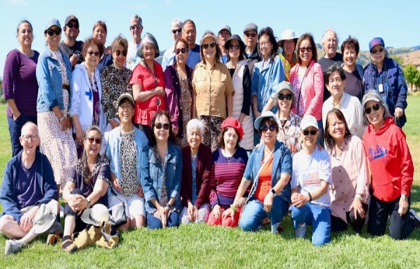
Please join Filipino-American Ministry on Wed., Sept 2nd as we come together in prayer: for Our Perpetual Help at 4pm. At 5pm we will gather in the hall for our monthly meeting as we discuss our parish picnic, our Saint Mass for our Filipino Saints, and Simbang Gabi in December. All our welcome to attend

The Men's Club Would like to thank all parishioners, their families and friends for attending our Annual Chicken Dinner. Great fellowship and food was enjoyed by all. A special thanks goes to Jo Ruminson and all the ladies who baked our delicious desserts. Thank you! Through the generosity of our members who donate most of the product, proceeds for the dinner totaled $3,219.69. Thank you to Bill Yates for delivering all leftovers to the less fortunate individuals at Labath Landing here in Rohnert Park. Congratulations to Linda Marlatt the lucky winner of the 50/50 Raffle. Proceeds from the dinner will go to the kitchen renovation. Thank you

Pastor’s Corner
I want to thank all those who said a prayer for me about my neck procedure at the doctor’s office. The six shots have relieved my pain at about 80% and I can sleep at night and I have more mobility but still must be careful not to strain my neck
Thank you to Cesira for the flowers this week. For the church sanctuary.
Thank you to Linda Marlatt, Jo & Larry Ruminson for coordinating the monthly Potluck. It is great to see more people coming.
I would like to meet with all Extra-Ordinary Ministers who want to bring Holy Communion to the sick on Sunday, Sept 6th after the 10:30 Mass.
The Wednesday evening Mass time has returned to 8:15 am


The Welcoming Church is for those adults interested in knowing about the the Catholic Faith. From their interest they may be drawn to the Lord to be:
- Baptized, receive Holy Communion and or be Confirmation.
- Those coming from another religious tradition and who are already baptized and wish to be received into the Church.
- Those who want to know more about their Catholic faith.
Applications are available across from the office on the 2nd shelf. We will begin these sessions on Wednesday, Oct 14th from 6-7:15pm. If there is a consensus after the first gathering, we can change the time to 7-8:15 pm.

Ministry Schedule Sept. 5th & 6th
4:00pm Mass
Readers: Linda Biondini, Tony Sacramento
EMS: Joanne Bishop, Luisa Bustillos, Tony Madia
Ushers: Mark & Selina Johnson
Greeters: Ron & Debra Ciarasso
8:30am Mass
Readers: Dolores Sanchez, Maureen Sheridan Scott
EMS: Remie Alinas, Larry Biondini, Patty Ramos
Ushers: Gus & Liz Chang
Greeters: Alan & Caroline Kalaw
10:30am Mass
Readers: Fred Adam, Nora John
EMS: Jovita Bishop, Victoria Gregorio, Nora John
Ushers: Augustine Gonzalez, Sally Shami
Greeters: Fred & Janet Adam
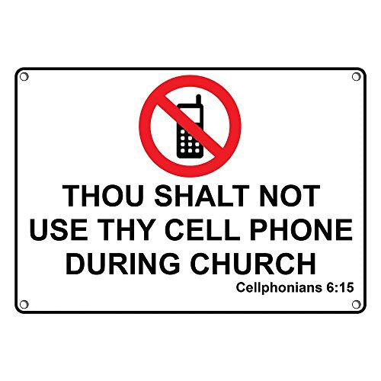

Youth Faith Formation
REGISTRATION CLOSES TODAY!


Please use the QR code provided or fill out a packet located in the vestibule. Families can turn in registration forms to the office, online or email sesreled@gmail.com. First Communion Classes begin on Wednesday, September 16th 1st Year Confirmation Parents & their teen will have an information meeting on Sun., Sept 13th after the 8:30am Mass in one of the classrooms.
Thank you to those who attended our training last Sunday and showed interest in supporting our youth.
If you would you like to learn more and walk with our older youth as they learn more about their faith, we will have a workshop later in September. Stay tuned for details.
WELCOME BACK TO FAITH FORMATION!
We hope you enjoyed your summer and made more memories with your family. We would like to thank you for including St. Elizabeth Ann Seton Parish in your family’s faith journey.
Schedules will be emailed out by September 4th. If you do not get an email, please email Jennifer at sesreled@gmail.com or text her at 707-888-9672. Schedules will also be available across from the office starting September 13th.
Sun., September 13th Grade 6th-12th
First Year Confirmation Level 1/CL
Wed., September 16th 1st Grade -5th Grade
First Communion Level 1 3:30-5pm/CL
First Communion Level 2 3:30-5pm/CL
Sun., September 20th Grade 6th-12th
2nd Year Confirmation Level 2/CL
Tues., October 13th CGS
Level 1 Ages 3-6 3:30-5pm/ L1 Atrium

The Parish is in need of Safe Environment Coordinator (SEC).
Maureen Sheridan-Scott has been volunteering her time for years and now it is time to turn the volunteer job over to someone else. Thank you Maureen for all the work you have done in keeping our members and others safe!
Responsibilities
The SEC acts as a liaison with the diocesan Office of Child and Youth Protection and oversees the implementation of diocesan policies and procedure at the parish and supports safe environmental programs, resources, Faith Formation, and promotes safety at the parish and awareness of April as National Child Abuse Prevention month. Ensure that
all appropriate personnel know the proper protocol when receiving an allegation of sexual abuse of a minor by someone within the Church.
The SEC is appointed by the pastor and responsible to him and the Director of Child and Youth Protection for the Diocese of Santa Rosa. Each SEC is essential in ensuring that the safe environmental programs,
policies, and procedures are being implemented throughout the parish.
This includes Code of Conduct for each participant.
Verify the names of all employees in the parish. Ensure that all employees and active volunteers are registered in Veritas. Verify that all employees and any volunteers having contact with children complete the training required. Not mandated, but highly recommended, is that Liturgical Ministers also be
fingerprinted and entered into Veritas. All Finance Volunteers and Eucharistic Ministers for the Homebound need to be fingerprinted. We
keep a file in the office for Homebound EMs drivers licenses and current auto insurance.
Work with Faith Formation Director regarding Circle of Grace for all grade levels and report numbers to the diocese and keep copies of all opt out letters signed by parent/guardian. Record keeping is important. Submit Parish/School Audit Reports: October 1, February 1, and May1.
Attend Diocesan meetings of SECs

Volunteers


Fr. Tom is in need of a few volunteers to assist him in making the Macaroni salads for the Parish Picnic. Can you help? Give Fr. Tom a call 707 545- 7610 #4. This should be Easy Peasy Lemon Squeezy
September is the Month of Our Lady of Sorrows
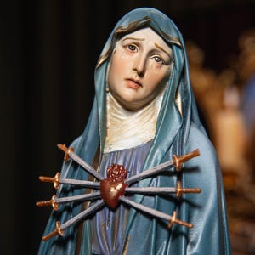
As the warmth of summer gives way to cooler evening breezes signaling the coming of Fall, we are reminded that the seasons of our lives bring change as well, triumph and joy, sacrifice and sorrow. The dedication of September invites Catholics to turn their hearts and minds towards the seven sorrows that marked the life of the Blessed Virgin Mary.
The Mother of Our Lord who gave birth to the Son of God in all joy and elation, was soon after to receive from St. Simeon the prophesy that would turn her joy into the deepest sorrow. St. Alphonsus Liguori tells us in The Glories of Mary that Our Lady’s martyrdom exceeds that of all the martyrs in that its duration was longer and the suffering greater than all others. As with all the monthly devotions in the Catholic Church, the development took place over time. Devotion to Our Mother of Sorrows, supported in Sacred Scripture, dates back to the early Church Fathers contemplating Mary’s sufferings at the foot of the cross. Throughout Church history, various orders and saints have had a special devotion to Our Lady under this title and as such, have focused their ministries on prayer and penance. September eventually became known as the month of Our Lady of Sorrows because Her feast day of that title had been fittingly appointed for September 15th, the day following The Exaltation of the Holy Cross.
Although The Blessed Virgin endured more interior pain than we can comprehend, the Church has given us seven sorrows on which we can meditate in identification with Our Mother of Sorrows. Our Lady herself has promised graces to those who honor Her in this way.
The Seven Sorrows are:
- St. Simeon’s Prophesy
- The Flight into Egypt
- The Loss of Jesus in the Temple
- The Meeting of Jesus and Mary on the Way of the Cross
- The Crucifixion
- Mary Receives the Body of Jesus taken down from the Cross
- The Burial of Jesus

Prayer to Our Lady of Sorrows
Our Mother of Sorrows, with strength from above you stood by the cross,
sharing in the sufferings of Jesus,
and with tender care you bore him
in your arms, mourning and weeping.
We praise you for your faith,
which accepted the life God planned for you.
We praise you for your hope,
which trusted that God would do great things in you.
We praise you for your love
in bearing with Jesus the sorrows of his passion.
Holy Mary, may we follow your example,
and stand by all your children who need comfort and love.
Mother of God,
stand by us in our trials and
care for us in our many needs.
Pray for us now and at the hour of our death.
Amen!

