St. Elizabeth Ann Seton Catholic Church 4595 Snyder Lane Rohnert Park, CA 94928 (707) 585-3708 Website:www.Stelizabethrp.com E-Mail stelizseton@sbcglobal.net Office Hours: Tue.- Wed. 9am - 1pm The Church is open weekdays 7:30–6:30pm, Saturdays & Sundays 7:30 - 5:15
January 18, 2026
Second Sunday in Ordinary Time

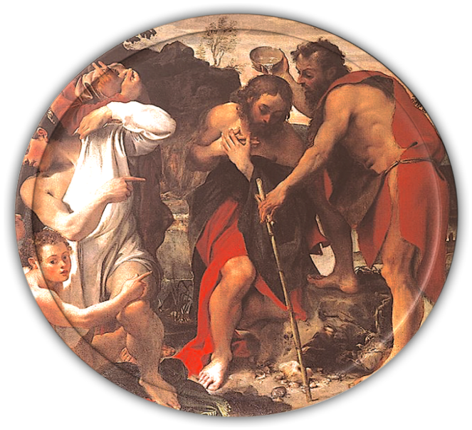

“On whomever you see the Spirit come down and remain, he is the one who will baptize with the Holy Spirit.”

Parish Staff
Pastor: Rev. Thomas Diaz #4 Office Manager: Chris Giacometti: #1
Mass times: #2
Youth Faith Formation: Jennifer Bedoka #3
Executive Board: Tony Madia/Chairperson, Linda Biondini/Vice Chairperson, Katie Chase, Larry Ruminson, Julie La Plante
Floral Decorations: Cesira Heric
Sacraments and Devotions
Reconciliation: Sundays: 9:45-10:15am, Thu 1-1:30
Marriage: One year notice to the pastor.
Infant Baptism: 1 month notice. The next preparation session will be on Feb. 15th at 4pm. for parents.
Anointing of the Sick: Please call Fr. Tom. Usually, it is celebrated after 10:30 Sunday Mass
The Rosary: ½ hr. before weekday Masses.
Divine Chaplet: Tuesdays after the12:15 Mass
The Welcoming Church: Sundays 1pm.
Exposition & Benediction Thur. 12:45-1:45pm.
Mass Schedule and Intentions for the Week
Sat/Jan 17 4:00pm. +Carmen Tursi
Sun/Jan 18 8:30am. People of the Parish
10:30am. +Abel Sagon
3:00pm. Santo Nino Mass
Tue/Jan 20 12:15pm. +Felix Rojas
Wed/Jan 21 8:15am. + Maryann Landis
Thu/Jan 22 12:15pm. +Eric Ponce
Fri/Jan 23 8:15am. Ints. Jeanne Fields
Sat/Jan 24 4:00pm. +Felix Rojas
Sun/Jan 25 8:30am. People of the Parish
10:30am. + Paul John Morales

Events in the Parish
Sun/Jan 18, 9:30am. SVDP Mtg/Hall
11:30am Hispanic Ministry Mtg/Hall
1pm. Welcoming Church
Tue/Jan 20, 1pm. Bible Study/ Hall

Stewardship
Plate Donations: January 10th & 11th $5,765. Building Maintenance $2,411. Thank you for your help in maintaining the church.
The second collection today is to help those in need in Latin America, Eastern Europe and Native Missions.

Homily Highlights from Last Sunday

- We are called to be the Beloved of God
- How do we show the Lord that we want to be called the Beloved?
- How do we listen to God?

Sunday Scripture Readings
Reading I: Isaiah 49:3,5-6, Reading II: 1 Corinthians 1:1-3, Gospel: John 1:29-34

Sunday Reflection

Failure The First Reading gives us something rare in Scripture: a dialogue between God the Father and the Messiah he sent. But if you look at the verse numbers of our First Reading, you will see that Verse 4 has been omitted.
The preceding Verse 3 is God’s line to the Messiah. my way of phrasing it would be, “you are my servant, and you will be a spectacular success; people will be able to see the glory of God by looking at you.”
All that success came only after the death of the Messiah.
This is a powerful expression of praise and affirmation, isn’t it?
But guess how the Messiah responds to God in the omitted Verse 4?
In the first of his two lines in Verse 4, the Messiah says (in my way of phrasing it), “I have labored in vain. I have used all my strength, and it has all been for nothing.”
This line is a powerful expression of failure, isn’t it?
You can see why someone might have thought Christ’s mission was a failure. The people passing by Christ on the cross certainly didn’t see the glory of God in him then! And by the time of his death, the work of Christ’s life had come only to this: he had a handful of disciples and a few women as hangers-on. If the goal was to bring salvation to the world, you can see that this result would look like total failure.
But here is the gist of what God says in Verses 5-6, in response to the Messiah’s expression of failure in Verse 4:
You are glorious in the sight of the Lord, and God is your strength. Just saving Israel is too small a success for you; you will bring salvation to all the ends of the earth.
The first communities of Christians and all the apostles were Jewish. By now there are Christian communities in every non-Jewish part of the earth, too. And so Christ’s mission to bring salvation to the Jews and the Gentiles was a glorious success, as in the First Reading God predicted it would be.
But all that success came only after the death of the Messiah.
Our success, like our glory, needs to be through God’s strength, in God’s sight, and in God’s time. And that is why, in the second of his two lines in the omitted Verse 4, the Messiah says, “my judgment is with the Lord, and my work is with my God.” Eleonore Stump

Family Connection

The ministry of John the Baptist prepared for and pointed to the ministry of Jesus. In a similar way, our lives are to offer testimony to who we know Jesus to be for us and for the world. Jesus is the Lamb of God who takes away the sins of the world. How does the witness of our lives give testimony to the reconciling presence of Christ?
As a family, identify as many titles for Jesus as possible, such as Lamb of God, Son of God, Prince of Peace, and so on. Talk together about what these different titles mean and what they tell you about Jesus. Then read together today’s Gospel, John 1:29-34.
Consider how John the Baptist gives testimony to who Jesus is. Talk about what people might come to know about Jesus by observing your family life. Pray together that your family life will show others that Jesus is the Son of God, the lamb who takes away the sins of the world. Pray the Lord’s Prayer.

Please pray for the health intentions of: Sherman Chan, Gus Chang, Mary Couto, Ginger Crawford, Patrick Dempsey, Lupita Diaz, Marcella Dorado, Anthony Eger, Evelyn Estrella, Jeanne Fields, Louise Galassi, Elsa Garcia, Dave Grundman, Theresa M, Nancy Keegan, Patricia Lauterjung, Kelly Limberg, Frank Manhoso, Charles Mc Collum, Larry Ng, Pat O’Brien, Robert Perrill, Mary Piccioni, Lisa Rivas, Patricia Sack, Robert Scarpone, Maureen Sheridan Scott, Carol Slack, Dominique & Cecilia Tarrant,
Malik and Mia Whitehorse. If you want a name on the list, please call the office.

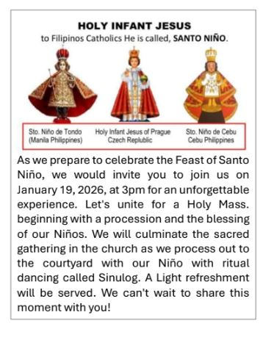
Today, Sunday at 3pm

Faith Formation Ministry
Quote of the Week
“However well you may, however you may wrestle, you will need Him who gives the crown”
St. Gregory Nazianzen
Sunday, January 18th
9:30 am 2nd^{t} Year Confirmation Class/CL
10:30 am Children’s Liturgy of the Word
5-6:30pm Youth Group/Hall
5-6:30pm pm Catechesis of the Good Shepherd L3/Atrium
Tuesday, January 20th
3:30-5 pm Catechesis of the Good Shepherd L1/Atrium
Wednesday, January 21st
3-4:30 pm 1st Year First Communion
3-4:30 pm 2nd Year First Communion
3-4:30 pm Catechesis of the Good Shepherd L3/Atrium
Sunday, January 25th
9:30 am 2nd Year Confirmation Class/CL
10:30 am Children’s Liturgy of the Word
5-6:30pm 1st Year Confirmation Class
5-6:30pm pm Catechesis of the Good Shepherd L3/Atrium

Thank you for supporting faith formation’s dine and donate you helped us raise $121.46
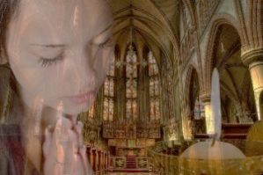
Do you pray each day? We are looking for parishioners to be prayer partners to students who will be receiving their sacraments this year. Please take time to think if this is something you can do for our Communicants and Confirmandi. if you are interested in this ministry Email sesreled@gmail.com


SV Admissions - Now Enrolling 9-12th Grades - Contact Kerry Pedersen to schedule your family tour at kpedersen@svhs-pet.org or (707)763-1032 x113.
- Values-based Education
- Exceptional Teachers
- Academic Rigor
- Personalized Instruction
- Individual Support
- 107-Year-Old Tradition
- Safe & Supportive Community
- Diverse Learning Opportunities

Social Justice Raffle
Beginning this weekend through January 25th your social justice ministry will be having a fundraiser to purchase food, to prepare meals for the needy of our community during the 2026 calendar year.
We will raffle off a roll of $1 lottery scratchers. There are 240 tickets in the roll. We will sell only 60 tickets, and the price will be $20 per ticket the tickets sell out quickly – we will buy a second roll and repeat the same raffle. and so on…. THANKS, AND GOD BLESS
The Social Justice Committee.

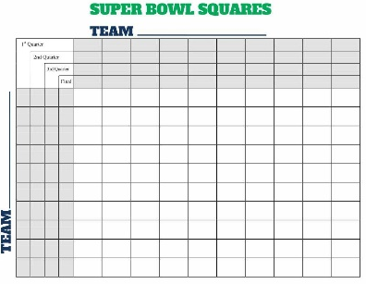
The Men’s Club will be sponsoring a Super Bowl Squares pool this year. Each Square is $20 and $1000.00 will be distributed as follows: 1st, 2nd, 3rd Quarters each $200, Final score will be $400, $1000 will benefit our Kitchen renovation. We will be selling the Squares after Mass mass beginning.

About the Kitchen Renovation. We can do very little with the Kitchen Renovation until we reach $75,000. At this time, we are $64,715 saved. A contractor is being consulted at this time to see how much the job will take. We need to remove a special wall, redo the hot water system, redo the plumbing and electrical for a new dishwasher, new countertops and sinks and possibly a new refrigerator, and flooring, etc. Be patient! A hot water not a chemical commercial dishwasher costs between $10,000-$17,000 dollars

Church Trivia Questions

- Who is the patron saint of missions, even though she never left her convent?
- What future apostle stood by watching the stoning of the Church's first martyr, Stephen?
Walk for Life West Coast 2026
Join fellow Catholics and Pro‐Lifers from all over California and beyond as we stand up for the littlest among us at the 22nd Annual Walk for Life West Coast in San Francisco on January 24, 2026. There will be Mass at 9:30am celebrated by Archbishop Salvatore Cordileone at St. Mary’s Cathedral. The rally begins at 12:30pm in San Francisco’s Civic Center Plaza, and the Walk, down the city’s Market Street, begins at 1:30pm. Bus Departure Information
St. Joseph Parish, Cotati Cost: $40 per seat (include light snack beverage) Students Ride Free Register at https://www.zeffy.com/en-US/ticketing/walk-for-life--2026
Cathedral of St. Eugene, Santa Rosa
Departure time: 7:30 AM Cost: $42.00
Payment is cash only and will be collected at the Cathedral of St. Eugene. More information: (707) 542-6984
Thursday is the Day of Prayer for the Legal Protection of Unborn Children
Prayer for the Unborn

Heavenly Father,
You are the Author of all life, the One who forms each soul in love and purpose.
We lift up every unborn child into Your care, asking for Your sheltering hand to guard them.
Bless mothers and fathers with courage, compassion, and the support they need to choose life.
Heal hearts wounded by loss, and bring peace to those who carry heavy burdens.
Guide leaders, communities, and each of us to defend the dignity of every human being,
from the first spark of life to the final breath.
May our words and actions reflect Your mercy and may love always be stronger than fear. Amen.
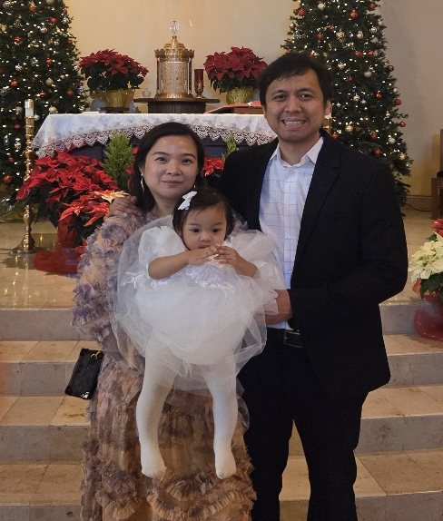

Congratulations to the Encarnacion Family on the baptism of their daughter Lierna on Dec 27th.

Pastor’s Corner

This week a letter will be going out dealing our parish finances, envelope usage and more. Also contained in the mailing will be information on the 2026 Annual Ministry Appeal. I thank all those who gave this past year and hope that more than 30% will participate in the appeal. The Diocese is mailing out the AMA mailing very soon.
Two people over the last two months have asked to be on a board for the kitchen/Hall Renovation. I have heard nothing from anyone else. Please get involved !

Ministry Schedule

January 17th & 18th
4pm Mass
Readers: Linda Anderson, Liz Ritchie
EMS: Janice Dyer, Tony Madia, Linda Mish
Ushers: Mark & Selina Johnson
Greeters: Roxanne Bialkoski, Luisa Bustillos
8:30am Mass
Readers: Phillip Alvarado, Maureen Sheridan Scott
EMS: Larry Biondini, John Buhagiar, Dave Grundman
Ushers: Remie Alinas, Sally Shami
Greeters: Larry & Jo Ruminson
10:30am Mass
Readers: Scott Morrical, Tony Sacramento
EMS: Jovita Bishop, Giovanna DeSimone, Victoria Gregorio
Ushers: Dianne Foppoli, Milagros Morrical

January 24th & 25th
4:00pm Mass
Readers: Linda Anderson, Linda Biondini
EMS: Gloria Bacani, Joanne Bishop, Tony Turegano
Ushers: Beth Turegano, Bill Yates
Greeters: Roxanne Bialkoski, Pat Yates
8:30am Mass
Readers: Phillip Alvarado, Maria Van Anne
EMS: Armando Argueto, Diane Cook, Maureen Sheridan Scott
Ushers: Remie Alinas, Mary Thayer
Greeters: Alan & Caroline Kalaw
10:30am Mass
Readers: Mary Denson, Nora John
EMS: Jovita Bishop, Luisa Bustillos, Linda Mish
Ushers: Scott & Milagros Morrical
Greeters: Fred Adam, Nativity Mata

Liturgical Ministers Please go to the table next to the SCRIP table to fill out the liturgical schedule. Remember to put 1st and 2nd choices.



