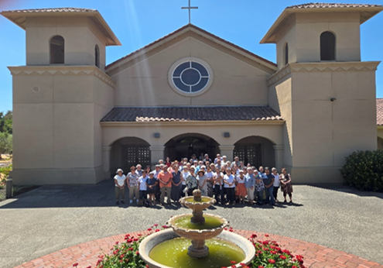
St. Elizabeth Ann Seton Parish 4595 Snyder Lane Rohnert Park, CA 94928 (707) 585-3708 Website: www.Stelizabethrp.com E-Mail stelizseton@sbcglobal.net Office Hours: Tue.- Fri. 9am - 1pm Church doors are open weekdays 7:30–6:30pm Saturdays & Sundays 7:30 - 5:15pm
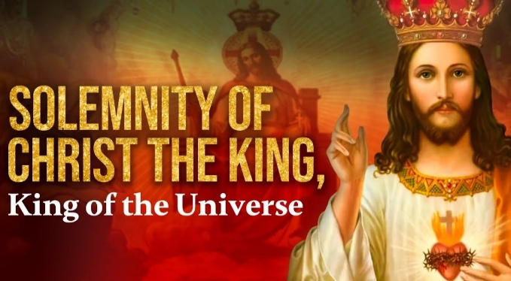
November 23, 2025
O Christ Jesus, I acknowledge You King of the Universe. All that has been created has been made for You. Exercise upon me all Your rights. I renew my baptismal promises renouncing Satan and all his works. I promise to lead a good Christian life and to do all in my power to procure the triumph of the rights of God and Your Church. Divine Heart of Jesus, I offer You my poor actions in order to obtain that all hearts may acknowledge Your sacred royalty and that thus the reign of Your peace may be established throughout the universe. Amen,
Parish Staff
Pastor: Rev. Thomas Diaz #4 Office Manager: Chris Giacometti: #1
Mass times: 2
Youth Faith Formation: Jennifer Bedoka #3
Executive Board: Tony Madia/Chairperson, Linda Biondini/Vice Chairperson, Katie Chase, Larry Ruminson, Julie La Plante
Floral Decorations: Cesira Heric
Sacraments and Devotions
Reconciliation: Sundays: 9:45-10:15am
Marriage: One year notice to the pastor.
Infant Baptism: 1month notice. The preparation session will be on Dec. 7th from 3-4:30pm in the hall.
Anointing of the Sick: Please call Fr. Tom. Usually, it is celebrated after 10:30 Sunday Mass
The Rosary: ½ hr. before weekday Masses.
Divine Chaplet: Tuesdays after the12:15 Mass
The Welcoming Church for Adults: This Sundays at 1pm/Hall

Homily Highlights from Last Sunday
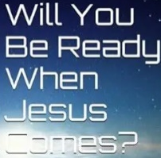
- The end of the world will take place when you least expect it.
- Some may not be here as the Lord has taken them
- We need to be ready when the Lord calls us as an individual or as a world, if we worry, we are not ready. But if we are ready, it will be a glorious time.
- Let us not get lazy waiting for the Lord but busy preparing for him.

Scripture Readings this Sunday
Reading I: 2 Samuel 5:1-3
Reading II: Colossians 1:12-20
Gospel: Luke 23:35-43


Christ the King In the Gospel Reading, Christ is crucified. The rulers who caused this crucifixion feel no compassion. They add to his misery by mocking his mission: he saved others; himself he cannot save. One of the two thieves crucified with him mocks him too: hey, Christ, save yourself and us! Christ the King says nothing. He just hangs there, nailed to the wood of the cross. What the other thief says is astonishing. He rebukes the first thief, the one mocking Jesus, in the strongest possible way. “Have you no fear of God? “ he says. If you leaned over the edge of your chair and saw a giant python inching its way across your floor, you would leap sky high, wouldn’t you? You wouldn’t be making any mocking jokes right then, would you? The good thief wants to get the same reaction out of the bad mocking thief. Only it isn’t a python that is meant to give the bad thief a reality check. It’s the awesome power of the living God. But how about a reality check for the good thief? Look at where Christ the King is! What’s to fear about the God who lets his King be killed this way? The whole earth is soaked with the tears of the suffering; and broken humanity is like the flotsam and jetsam everywhere on the ocean of history. What’s to fear about God? Where is he? On the cross—that is the answer God is love and all the power of God is there in the love shown by Christ’s painful death. To save us, and to bring us to himself in heaven, God will suffer even the torment of death on the cross. Love that is willing to suffer is greater than power that is able to coerce, and that powerful love is there on the cross. Someone habituated to mockery should fear this power. Sooner or later, the consuming fire of God’s love will burn away his mockery’s pretense at insouciance. But someone who fears God because God loves him will find Christ in the way the good thief did. Sooner or later, he will hear Christ say to him, “This day you will be with me in paradise.” Then he will know the victory of Christ the King, and he will be victorious with Christ. Eleonore Stump
Discussion Question: From the beginning of his life to his last act, Jesus revealed himself as Mercy. What does that mean to you.
Family Connection Today as a Church, we conclude our liturgical year and celebrate the Feast of Christ the King. The Gospel we proclaim shows the great mystery of our faith: In the moment of his crucifixion, Jesus is shown to be King and Savior of all. Luke's Gospel has been loaded with surprises: the poor are rich, sinners find salvation, the Kingdom of God is found in our midst. Here we see the greatest surprise of all. We are confronted with the crucified Jesus, whom faith tells us is King and Savior of all. The irony is that the inscription placed on the cross, perhaps in mockery, contains the profoundest of truth. As the leaders jeered, the thief crucified by his side recognizes Jesus as Messiah and King and finds salvation. Jesus is King, but not the kind of king we might have imagined or expected. His kingship was hidden from many of his contemporaries, but those who had the eyes of faith were able to see. As modern disciples of Jesus, we, too, struggle at times to recognize Jesus as King. Today's Gospel invites us to make our own judgment. With eyes of faith, we, too, recognize that Jesus, the crucified One, is indeed King and Savior of all.
Parish Stewardship for November 15 & 16: Plate: $4,897. Liability Insurance: $1,968. Thank you for your generosity. Collection on Thanksgiving Day will be for Adult Faith Formation as we have 29 people involved with The Welcoming Church
Mass Schedule and Intentions for the Week
Sat/Nov. 22, 4pm +Abel Sagon
Sun/Nov. 23, 8:30am People of the Parish
1 0:30am +Fructoso & Marta Sandoval
Tue/Nov. 25, 12:15pm All Souls
Wed/Nov. 26, 12:15pm All Souls
Thu/Nov. 27, 9:00am All Souls
Fri/Nov. 28, 12:15pm All Souls
Sat/Nov. 29, 4pm +Abel Sagon
Sun/Nov. 30, 8:30am People of the Parish 10:30am +Carl Sagon & Shelley Edmondson
Events for the Week Sat/Nov 22, 5-7 Tamale pickup Hall Sun/Nov 23, 1 pm Welcoming Church Thu/9am Thanksgiving Day Mass Sun/Nov 30 No Welcoming Church Session
Faith Formation Ministry
Quote of the Week
“Do not be afraid to be saints.”
Pope St. John Paul II

Sunday, November 23rd
10:30 am Children’s Liturgy of the Word

Sunday, November 30th
10:30 am Children’s Liturgy of the Word

No classes November 23rd, 26 th,30th
Faith Formation wishes you a Happy Thanksgiving Break!
Parent and child meetings have started, please check your email for availability in November or December for a meeting!

Are you interested in hearing about Catechesis of the Good Shepherd for your child, please contact us for information?
Email sesreled@gmail.com if you’re interested in joining our ministry!

Pastor’s Corner I will be away this week and return on Sat. eve. While I am away the Mass schedule will change on the weekdays. I thank Fr. Christopher from the Newman Center for covering Tues. Mass at 12:15 and the Thanksgiving Day Mass at 9am. I want to thank Fr. Culligan for covering Mass on Wed. at 12:15 & Fri. at 12:15. I want to thank Msgr. Whelton for covering the Sat. Vigil Mass at 4. If there are any emergencies (sickness) please call St Joseph’s at 707 795-4807. If the secretary does not come on with the phone number given ask for ex 113 The Social Justice Ministry. The generosity of our Parish resulted in over 50 large bags of clothing for the Unsheltered Friends Outreach (UFO) during our October clothing drive. Paula Brown (Chairperson of the UFO) told us that this will supply her dependents for the whole winter season and expressed her sincere gratitude. Our Men’s Club donated sufficient pasta to the Sam Jones Homeless Shelter to feed 140 people, Friday 14th of November, at the request of members of Social Justice. This was also met with warm gratitude. “Whatever you did for these – you did for ME”. Thank You!

offers heartfelt thanks to the Women's Guild for their support of our Christmas Basket Program. Your $1000 donation helps with the purchase of turkeys, hams and chickens for our needy family's Christmas dinners. God bless you for partnering with us in doing God's work to brighten our neighbors Christmas. SVDP, with the help of our parishioners, will provide a Christmas Basket with dinner items for 90 needy families. Each basket will include one of the following: Ham, Chicken, or Turkey. We are going to collect specific food items each week for the Christmas Basket, starting on Saturday, November 29th, and ending on Sunday, December 14th. We will be collecting specific food items each week, based on the following dates:
Dates Size Item
Nov 29/30 20 oz can Pineapple slices Dec 6/7 13 oz box Instant Mashed Potatoes Dec 13/14 1 box Hot Chocolate (8 Servings) Food donations can be placed in the baskets that are located next to the church bulletin board, beginning Saturday, November 29th. Monetary donations for the food items, hams, chickens, and turkeys, can be placed in an envelope marked “Christmas Basket”, with the checks made out to SVDP and dropped off at the church office or in the Sunday collection. We are also asking for donations of $10 Scrip cards from Target or Wal-Mart for gifts for needy families. These Scrip cards can be placed on the Giving Christmas Tree, located at the church entrance, starting on Saturday, November 29th. Christmas Baskets of food will be delivered on Saturday, December 20th. Parishioners who are interested in helping to deliver the Christmas Baskets can contact Larry Ruminson at 707-548-7058 or email him at BigLarr2@aol.com.
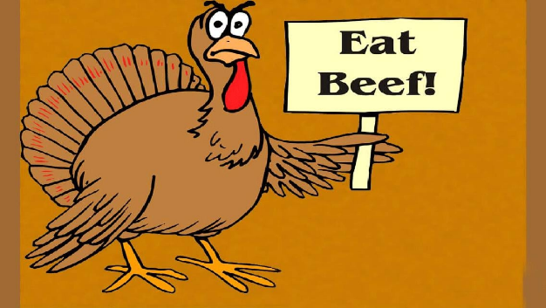

Use Scrip for all your holiday needs. We have grocery stores for your holiday meals, merchants for purchasing gifts or giving gift cards and restaurants for dining out: Grocery Stores: Raley’s, Safeway and Walmart. Restaurants/Food: Applebee’s, Chili’s, Cold Stone, Olive Garden, See’s Candy, Starbucks. Other Stores/Merchants: Amazon, Home Depot, Target, Wal-Mart, Tip-Top Cleaners (limited supply) Gas Stations: Arco Gas (limited supply), Shell Gas You can place a special Scrip order for other retailers that we do not keep in stock. We have a current list as of 11-13-25 at the Scrip table, a copy in the office or go online to the following link: raiseright.com/resources/participant When the page opens click on Download PDF under the Brands List on the right side.
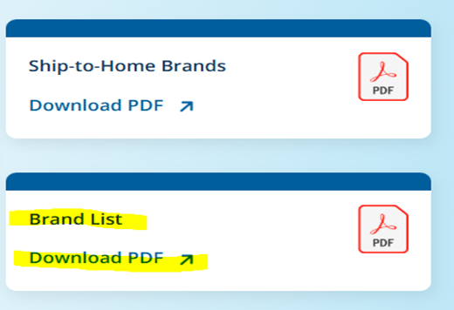

To place a Scrip special order: fill out a Scrip receipt with your name, phone number, and date at the top, write in the store/retailer you want in the blank spaces at the bottom, include how many cards and what denomination you want them in ($10, $25, etc.) make sure you check the current list to see what denominations are available for that retailer. Only include special order stores on this receipt. Pay for the special order by check or cash. Note special orders will not be placed without paying for them in advance. Special orders will be placed at the same time as our typical orders (usually on Sunday) and providing Raise Right has the inventory we could have the scrip the following weekend. For questions call Carol Blais (707) 322-0899 or Roger Blais (707) 322-3382 or Email us at ses.scriprp@gmail.com All profits from our scrip program benefit St. Elizabeth Seton landscaping around our parish. The more that we participate the more we can grow. Thank you for your support

Hall Renovation Committee for the Inside I am looking for a team of men and women to dream with me on how to remodel the hall. If you are a contractor, an architect, one that has good ideas about how things are to be done and have good taste, in designing sign up at the office in the next few weeks.
OFFICE UPDATE The office will be closed on Thursday November 27th and Friday November 28th in observance of the Thanksgiving Holiday.
November 22 & 23
4:00pm Mass
Readers: Heigi Pillor, Tony Sacramento EMS: Gloria Bacani, Jovita Bishop, Linda Mish
Ushers: Mark & Selina Johnson
Greeters: Luisa Bustillos, Olivia Salazar
8:30am Mass
Readers: Liz Ritchie, Dolores Sanchez
EMS: Armando Argueta, Diane Cook, Dave Grundman
Ushers: Liz Chang, Sally Shami
Greeters: Alan & Caroline Kalaw
10:30am Mass
Readers: Scott Crossen, Marie Horwitz
EMS: Giovanna Desimone, Dianne Foppoli, Nora John
Ushers: Dianne Foppoli, Barry Goff
Greeters: Nativity Mata, Tony Piazza
9am Nov. 27 Thanksgiving Mass
Readers: Linda Biondini, Maureen Sheridan Scott
EMS: Armando Argueta, Jovita Bishop, Beth Turegano
Ushers: Olivia Salazar, Bill Yates
Greeters: Ron & Debra Ciarasso
November 29th & 30th
4:00pm Mass
Readers: Linda Biondini, Tony Sacramento
EMS: Larry Biondini, Janice Dyer, Beth Turegano
Ushers: Selina Johnson, Tony Turegano
Greeters: Sally Shami, Pat Yates
8:30am Mass
Readers: Phillip Alvarado, Maria Van Anne
EMS: Diane Cook, Victoria Gregorio, Mary Thayer
Ushers: Liz Ritchie, Mary Thayer
Greeters: Patty Ramos, Diane Van Anne
10:30am Mass
Readers: Milagros Morrical, Scott Morical
EMS: Jovita Bishop, Giovanna DeSimone, Nora John
Ushers: Scott Morrical, Sally Shami
Greeters: Fred & Janet Adam

Please pray for the health intentions for: Sherman Chan, Gus Chang, Mary Couto, Patrick Dempsey, Lupita Diaz, Marcella Dorado, Anthony Eger, Evelyn Estrella, Jeanne Fields, Louise Galassi, Elsa Garcia, Dave Grundman, Theresa M, Nancy Keegan, Patricia Lauterjung, Kelly Limberg, Frank Manhoso, Charles Mc Collum, Larry Ng, Robert Perrill, Mary Piccioni, Lisa Rivas, Robert Scarpone, Kathleen Schick, Maureen Sheridan Scott, Dominique & Cecilia Tarrant, Jessica Thompson, Malik Whitehorse. If you want a name on the list, please call the office.

Catholic Prison Ministry On Saturday, December 6, Il Poverello Fraternity of the Secular Franciscan Order will present a panel discussion on the Restorative Justice Ministry in the Santa Rosa Diocese.

Our presenters are Reverend Christopher Agoha, Santa Rosa Diocese coordinator for Prison Ministries, and Director of the Sonoma State Newman Center AND Deacon Jim Carr, who has participated in the Kairos Prison Ministry at San Quentin State Prison for the past 25 years.

Location: St James multi-use room, 125 Sonoma Mtn. Pkwy., Petaluma, CA

Date: Saturday, December 6; Time: 10 AM – 2 PM, snacks and drinks provided

Bring a bagged lunch if desired

For your RSVP or more information please contact Edd J Ringlein, OFS, Minister

Email: ejringlein.ofs@gmail.com; Cell Phone (text): 707-2465311
A Prayer of Thanksgiving, by Msgr. Gerard Fahey
For Creating us, we thank you Lord For Redeeming us, we thank you Lord For Loving us, we thank you Lord For Calling us by name, we thank you Lord For our Baptism, we thank you Lord For our Faith, we thank you Lord For our Holy Communion, we thank you Lord For the Gift we are to others, we thank you Lord For our Families, we thank you Lord For the Children in our lives, we thank you Lord For the sound of Laughter, we thank you Lord For the beauty of Song, we thank you Lord For the magnificence of our Surroundings, we thank you Lord For the Air we breathe, we thank you Lord For the Water we drink, we thank you Lord For the Health we enjoy, we thank you Lord For Sunshine and Rain, we thank you Lord For changing Seasons, we thank you Lord For our own Resurrection, we thank you Lord For all our Benefactors, we thank you Lord For our Parents, we thank you Lord For all your Gifts, we thank you Lord Monsignor Fahey(May he rest in peace) Amen.
