St. Elizabeth Ann Seton Catholic Church 4595 Snyder Lane Rohnert Park, CA 94928 (707) 585-3708 Website:www.Stelizabethrp.com E-Mail stelizseton@sbcglobal.net Office Hours: Tue.- Fri. 9am - 1pm The Church is open weekdays 7:30–6:30pm, Saturdays & Sundays 7:30 - 5:30pm

April 5, 2026
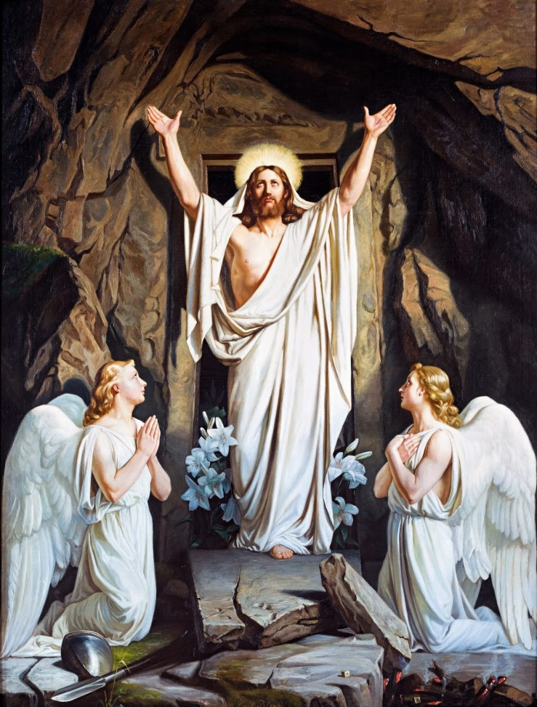
Easter Sunday of the Resurrection of the Lord

Parish Staff
Pastor: Rev. Thomas Diaz #4 Office Manager: Chris Giacometti: #1
Mass times: #2
Youth Faith Formation: Jennifer Bedoka #3
Executive Board: Tony Madia/Chairperson, Linda Biondini/Vice Chairperson, Katie Chase, Larry Ruminson, Diane Colbrook
Floral Decorations: Cesira Heric
Sacraments and Devotions
Reconciliation: Sundays: 9:45-10:15am, Thursdays: 12:45-1:45pm.
Marriage: One year notice to the pastor.
Infant Baptism: 1 month notice. The preparation session will be on April 26th 3:30pm/Hall
Anointing of the Sick: Please call Fr. Tom. Usually, it is celebrated after 10:30 Sunday Mass
The Rosary: ½ hr. before weekday Masses.
Divine Chaplet: Tuesdays after the12:15 Mass
The Welcoming Church: Next Sunday at 1pm.
Exposition & Benediction: Thu.12:15-1:45pm.
Mass Schedule and Intentions for the Week
Sat/Apr 4 8pm Special Intentions
Sun/Apr 5 8:30am For the Parish
10:30am Special Intention
Tue/Apr 7 12:15pm +Michael Foppoli
Wed/Apr 8 8:15am +Felix Rojas
Thu/Apr 9 12:15pm Ints. of Maureen Sheridan Scott
Fri/Apr 10 8:15am +Frank & Helen Stranzl
Sat/Apr 11 4pm +Felix Rojas
Sun/Apr 12 8:30am For the Parish
10:30am +Felix Rojas

Events in the Parish this Week
Mon/Apr 6 6pm Men’s Club Mtg/Hall

Stewardship for the Month of March 3/1 $4,835, 3/8 $5,183, 3/15 $4,951, 3/22 $5,041
3/29 $5,123. On-Line giving for March $1,389.78
Average Sunday Regular Collection: $5,304.55 Church Maintenance $2,183.
Catholic Relief & Home Missions $1,993.

Last Sunday’s Homily Highlights
- Palm Sunday was a day of praise
- Good Friday was a day of death
- What happened to the crowds in 6 days
- The crowds were fickle.
- What kind of a crowd are we involved in?

Sunday Scripture Readings
Reading I: Acts of the Apostles 10:34a, 37-43
Reading II: Colossians 3:1-4, Gospel: John 20:1-9

Sunday Reflection

God Is Always at Work Easter is the most important feast in the Catholic liturgical calendar, as it celebrates the Resurrection of Jesus Christ from the dead. Through his death and Resurrection, Jesus has triumphed over sin and death, and offers us the hope of new life and salvation.
The readings for Easter Vigil and Easter Sunday remind us of God’s goodness, power, and saving work throughout history. From the Creation Story to the Exodus from Egypt, God has been at work, leading his people to freedom and new life. In the Epistle reading, St. Paul exhorts us to die to sin and live for God, emphasizing the importance of baptism and faith in Jesus. And in the Gospel reading, we hear the amazing news of Jesus’ Resurrection, which brings hope and new life to all who believe.
A Message of Hope
This message of hope is especially important in our world today, where there is so much suffering, pain, and despair. We are all touched by the effects of sin and death, whether in our own lives or in the lives of those around us. But the Resurrection of Jesus offers us a way out of this darkness. It reminds us that death is not the final word, and that God never abandons us, even in our darkest moments.
As we celebrate Easter, we are called to let go of sin and selfishness, and to embrace the new life and hope that Jesus offers. We are called to let Easter change our hearts and transform our lives, so that we may become more fully the people that God created us to be. We are called to be bearers of hope and agents of new life, bringing the light of Christ to a world that is so often shrouded in darkness.
Meaning through Faith
Luke’s writings in the Bible remind us that God sent his Son to free us from sin and death and to live without fear. This message is just as important today as it was in the time of the early Christians. Sometimes, religion can become focused on ceremony and lose its true meaning. The Resurrection of Jesus is a powerful reminder of the transformative power of our faith.
The message of the empty tomb was initially confusing to the disciples. They couldn’t understand where the body had gone and what had happened. However, when they were reminded of Jesus’ words, the message began to make sense to them. Similarly, the experiences of our lives can sometimes be confusing and difficult to interpret without faith. We need to remember that, through the Resurrection, God has the power to transform our lives.
The early disciples were so energized by the shock of the Resurrection that nothing, not even death or persecution, could stop them from spreading the Good News. We too, as Christians, must be willing to hear the message of transformation and then spread it to others. We should not keep the Good News to ourselves, but share it with others so that they too can experience the joy and hope that comes from knowing Jesus.
So let us rejoice and be glad this Easter, as we celebrate the triumph of Jesus over sin and death. Let us give thanks to God for the gift of new life, and let us renew our commitment to follow Jesus, the risen Lord, wherever he may lead us. May the hope and joy of Easter fill our hearts and our lives, now and always.

Discussion Question: What areas of your life need transformation through the Resurrection?

Sunday Family Connection

The commercialism of Easter—costumed bunnies in the mall, Easter baskets full of candy and small toys, new clothes—often misdirects children’s understanding and celebration of this greatest of Church feasts. When spoken of as the Resurrection of Jesus Christ, today’s liturgical celebration may not stir excitement among them. Encourage your children to think about the real significance of this feast by using their creative skills to imagine this Easter Vigil’s Resurrection account in Matthew 28:1–10.
Read Matthew 28:1–10 as a family, letting the children take the roles of the angel and Jesus. Set up the narrative by speculating on how sad the women must have felt as they approached the tomb. Talk about the excitement of the two women who saw the empty tomb and heard the angel explain that Jesus was raised from the dead. Wonder together about how it must have felt to embrace the risen Lord as the women did. Imagine with your children the enthusiasm the women must have felt when sent to tell the disciples that Jesus was raised from the dead.
Remind them that today we remember and celebrate all that Jesus did to win entry to Heaven for us. Create together a colorful ALLELUIA banner to display in your home to celebrate Jesus Christ’s glorious Resurrection. Then stand, praying together today and throughout the Easter season: Alleluia, Alleluia, Jesus is risen, Alleluia!

Quote of the Week
“We are an Easter people and Alleluia is our song!” St. John Paul II
Sunday, April 5th
No Class 2nd Year Confirmation Class/CL
10:30 am Children’s Liturgy of the Word/Hall
No Class 1st Year Confirmation Class/CL
5 No Class Catechesis of the Good Shepherd L3/Atrium
After 10:30 am Mass All ages are welcome to join the Easter Egg Hunt
Tuesday, April 7th
3:30 pm Catechesis of the Good Shepherd L1/Atrium
Wednesday, April 8th
3 pm 1st Year First Communion
3 pm 2nd Year First Communion
3 pm Catechesis of the Good Shepherd L3/Atrium
Sunday, April 12th
9:30 am 2nd Year Confirmation Class/CL
10:30 am Children’s Liturgy of the Word/Hall
5 pm 1st Year Confirmation Class/CL
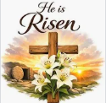
5 pm Class Catechesis of the Good Shepherd L3/Atrium

Faith Formation Registration is opened, and packets are available this weekend at the Faith Formation table.

Night of Peace Tickets are available for the May 3rd Concert. Stop by the formation table for all parishioners who are interested in attending.

Does your child/ren want to serve or need service hours, please inquire at the email address below.

Email sesreled@gmail.com if you’re interested in joining our ministry!

Pastor’s Corner
Brian Sennello after leading the music and choir at the 8:30 am. Mass on Sundays and assisting with accompaniment at the 10:30 Mass, will be stepping down to help out in a Catholic parish in Oakland, He will be by at times to assist us when there is an emergency on Saturdays
May God Bless you!

Please pray for the health intentions of: Luis Rangel Alvarez, Sara Bardoni, Patrick Bohn, Sherman Chan, Gus Chang, Jeanette Collins, Mary Couto, Patrick Dempsey, Giovanna Desimone, Lupita Diaz, Marcella Dorado, Anthony Eger, Evelyn Estrella, ,Cedric Fontana, Kathy Fontana, Louise Galassi, Elsa Garcia, Rosa Gomez, Dave Grundman, Kathleen, Nancy Keegan, Kelly Limberg, Theresa M, Frank Manhoso, Rudy Melano, Charles McCollum, Kevin McDonough, Richard Miller, Larry Ng, Pat O’Brien, Robert Perrill, Mary Piccioni, April Piehoff, James Reynolds, Claire Ribeiro, Marie Ribeiro, Lisa Rivas, Patricia Sack, Robert Scarpone, Patricia Stiefer, Dominique & Cecilia Tarrant, Jim Turegano, and Malik Whitehorse.

If you want a name on the list, please call the office.

Easter Basket, 2026 St. Vincent De Paul (SVDP) wants to thank all of the parishioners for their donations of food items and money towards the Easter Baskets.
Your contributions enabled SVDP to provide fifty-two families with 1,716 lbs. of food for Easter Meals. Each family received food items, along with one of the following: ham or chickens.
A SPECIAL THANK YOU goes out the following individuals who made it possible to do the Easter Baskets:
The bagging of the baskets was done by Larry Ruminson, Tricia/Fred Petersen, and Tony Turegano and the deliveries of the Easter Baskets were done by the following team members:
Team A -Nicole/Christopher Ybarra
Team B- Tony Turegano /Jim Griffen
Team C- Mila/Scott Morrical
Team D- Sherie Breining/Nora John
Team F- Sue/John Buhagiar
Team H- Diane Cook/Mary Thayer
Team R- Giovanna Desimone/Julie La Plante
Help with loading: John Ybarra

SES Women’s Guild Scholarship The SES Women’s Guild is excited to announce we are now accepting applications for the 2026 scholarship program. The scholarship amount is $1,000.
This will be awarded to a graduating high school senior student who plans to attend a college, university, or trade school.
Eligibility: be a practicing catholic and member of the SEAS parish and in good standing academically with their current school/education program
Applications can be picked up in the parish office.
Deadline: turn into the parish office by Thursday, April 30, 2026
Ministry Schedule April 11th & 12th
4pm Mass
Readers: Linda Anderson, Tony Sacramento
EMS: Luisa Bustillos, Dianne Foppoli, Tony Madia
Ushers: Liz Ritchie, Beth Turegano
Greeterst: Roxanne Bialkoski, Luisa Bustillos

8:30am Mass
Re: Readers: Scott Crossen Dolores Sanchez
EMS: Remie Alinas, John Buhagiar, Diane Cook
Ushers: Gus & Liz Chang
Greeters: Alan & Caroline Kalaw
10:30am Mass
Readers: Scott & Mila Morrical
EMS: Nora John, Julie LaPlante, Nativity Mata
Ushers: Scott Morrical, Sally Shami
Greeters: Giovanna DeSimone, Augustine Gonzalez
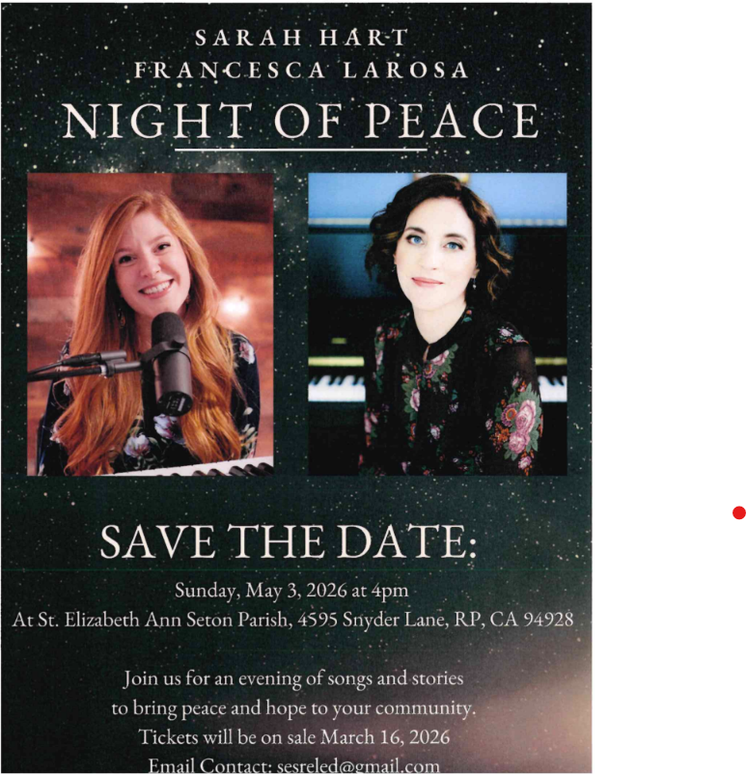



This is the day the Lord has made! Let us rejoice and be glad!

Mr. and Mrs. Fred Adam
Ms. Babylyn Aguilar
Mr. and Mrs. David Alinas
Ms. Nana Amoa
Mr. and Mrs. Norman Anslow
Mr. and Mrs. Charles Antonetti
Ms. Erika Araiza
Mr. and Mrs. James Arend
Mr. and Mrs. Manuel Bacani
Mr. and Mrs. Richard Balluff
Mrs. Elena Bates
Mr. and Mrs. Brian Bedoka
Ms. Gloria Beltran
Mr. and Mrs. Scott Berg
Mrs. Roxanne Bialkoski
Mrs. Mary Bianchi
Mr. and Mrs. Lawrence L. Biondini
Mr. and Mrs. David Bishop
Mr. and Mrs. William Black
Mr. and Mrs. Roger Blais
Mr. and Mrs. Richard Bohan
Mr. and Mrs. Carlos Botelho
Mrs. Sherie Breining
Mrs. Moira Bromham
Mr. and Mrs. John Buhagiar
Mr. and Mrs. Ken Burge
Ms. Eileen Bury
Mr. and Mrs. John Bustillos
Mr. and Mrs. Eugene Buvelot
Mr. and Mrs. Terry Cadigan
Tiffany and Jose Calvillo
Vestre Capson
Mr. and Mrs. Sherman Chan
Mr. and Mrs. Augustine Chang
Ms. Lillian Ciarasso
Mr. and Mrs. Ronald Ciarasso
Mr. and Mrs. TK Clarke
Mrs. Diane Colbrook
Ms. Gina Contolini
Mr. and Mrs. Carlos Contreras
Ms. Diane Cook
Mr. and Mrs. Stanley Cordero
Ms. Suzanne Cossette
Mr. and Mrs. Salvatore Crisafulli
Mr. Scott Crossen
Mr. and Mrs. Jon Curry
Mrs. Lorraine Datu
Ms. Barbara Dede
Mr. and Mrs. William E. Denson
Mrs. Giovanna DeSimone
Ms. Diane Deutsch
Rev. Thomas Diaz
Ms. Olga Dorado
Mr. and Mrs. Gary R. Dyer
Mr. and Mrs. Jesus Espinoza Renteria
Ms. Aida Agnes Estrada
Ms. Marie Felis
Mr. and Mrs. Michael Fontana
Mrs. Dianne M Foppoli
Mr. Miguel Gamboa
Mr. and Mrs. Rigoberto Gamino
Mr. and Mrs. Pedro Garcia
Mr. Christopher Gay
Mr. and Mrs. Lorin Giacometti
Mr. and Mrs. Bob Ginn
Mr. Gary Girard
Ms. Clare Giu
Mr. and Mrs. Barry Goff
Mrs. Emilia Gomez
Mr. and Mrs. Miguel Gomez
Mr. Mark Gondree
Ms. Debra Greenblat
Mr. and Mrs. Arthur Gregorio
Mr. and Mrs. Tim Griesser
Mr. and Mrs. James Griffin
Mr. David Grundman
Mrs. Cesira Heric
Ms. Denise Hernandez
Ms. Marie Horwitz
Mrs. Nora John
Mr. and Mrs. Mark Johnson
Mr. and Mrs. Allan Kalaw
Mrs. Lisa Kellogg
Mr. David Kosmala
Ms. Julie La Plante
Mr. and Mrs. Joselito Labrador
Mrs. Isabel Ladd Larsen
Mr. and Mrs. Thomas LaFreniere
Mr. and Mrs. Scott Laube
Mr. and Mrs. Bernard Lica
Benedict and Christina Lizama
Mr. and Mrs. James A. Lowy
Mr. David Lukes
Krystle and Patrick Madayag
Mr. and Mrs. Tony Madia
Mr. and Mrs. Thomas Makin
Mr. and Mrs. John Maloney
Mrs. Linda Marlatt
Mr. and Mrs. Joe Medeiros
Mr. and Mrs. Richard Miller
Mr. and Mrs. William Mish
Ms. Cynthia Montalvan
Mr. and Mrs. Chris Moret
Mr. and Mrs. Dennis Morley
Mr. and Mrs. Frank Moro
Mr. and Mrs. Scott Morrical
Mr. and Mrs Albert Mouttapa
Ms. Victoria Mwangi
Ms. Ana Naivalucava
Mrs. Judy Nelson
Ms. Judith Oberoi
Mr. and Mrs. Aldo Ochoa
Mrs. Carol J. O'Donnell
Mr. and Mrs. Juan Carlos Padilla
Mr. and Mrs. Louis Padilla
Mr. Rolando Pangilinan
Mr. and Mrs. Rex Patangan
Mr. and Mrs. Frederick W. Petersen
Mr. and Mrs. Tony Piazza
Ms. Marcela Piedra
Mr. and Mrs. David Pillor
John and Mary Rose Pott
Mr. and Mrs. Rodolfo Pring
Ms. Dana Proctor
Mr. and Mrs. Christopher Quinones
Mr. and Mrs. Alfredo A. Ramos
Mr. and Mrs. Virgilio Ranada
Mr. and Mrs. Michael Rantissi
Mr. and Mrs. Lito Relota
Mr. and Mrs. Ricardo Resendiz
Mrs. Francia Rico
Mrs. Elizabeth Ritchie
Ms. Erin Rock
Mr. and Mrs. Larry Ruminson
Mr. and Mrs. James E. Ruzicka
Mr. Antonio Sacramento
Mrs. Priscilla Sagon
Mr. and Mrs. Napoleon Salazar
Mrs. Dolores Sanchez
Mr. and Mrs. Richard Schultz
Mr. Brian Sennello
Ms. Elvira Seno
Mr. and Mrs. Mitri Shami
Mr. and Mrs. Kenneth Shane
Ms. Maureen Sheridan Scott
Mr. and Mrs. Jerome Smith
Mr. and Mrs. Kent Smith
Mr. Aidan Spencer
Ms. Myriam Spitalier
Ms. Patti Stadler
Ms. Melanie Stahlnecker
Mr. and Mrs. Garfield Sterner
Mr. and Mrs. Andy S. Tam
Mrs. Mary Thayer
Ms. Elsie C. Timan
Mr. and Mrs. Anthony Turegano
Ms. Stephanie Valentino
Mr. and Mrs. Duane Van Anne
Mr. Matthew Vaughn
Mr. and Mrs. Bert Vega
Mr. and Mrs. Emilio Velazquez
Mr. and Mrs. Jose Villaceran
Mr. David Vondrak
Mr. and Mrs. Nicholas Vondrak
Mr. and Mrs. Randall Vondrak
Ms. Luisa Wagy
Mr. and Mrs. Neil Way
Mrs. Janice Wright
Mr. and Mrs. Christopher Ybarra
Mr. and Mrs. Michael Zieff
Ms. Sonia Zuniga

We, the parish, thank all those who have given to the Diocesan Ministry Appeal through March 31st
Goal: $19,300-Pledges: $62,849-Gifts Received: $37,535-Rebate: $18,235
Families so far 179=31% of the Registered Parish Families
The Diocesan Ministry Appeal Drive ends on Dec 31st.

