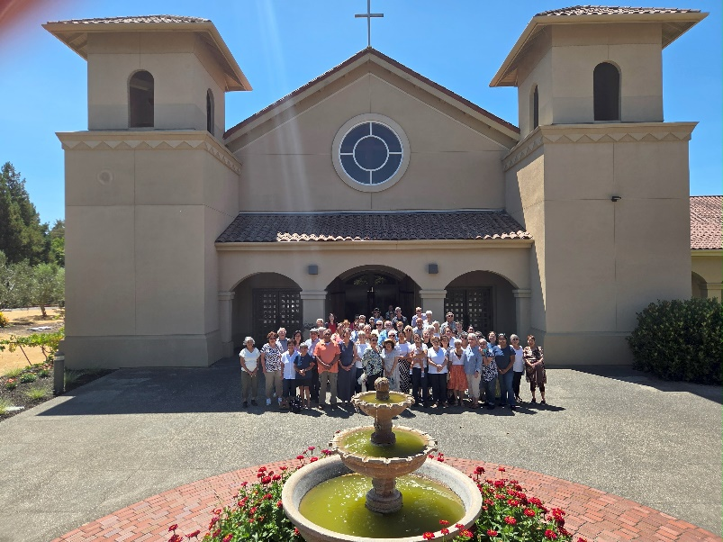
St. Elizabeth Ann Seton Parish 4595 Snyder Lane Rohnert Park, CA 94928 (707) 585-3708 Website: www.Stelizabethrp.com E-Mail stelizseton@sbcglobal.net Office Hours: Tues. through Fri. 9am. - 1pm Church doors open from 7:30am –7pm.
Oct.12, 2025, 28th Sunday of Ordinary Time
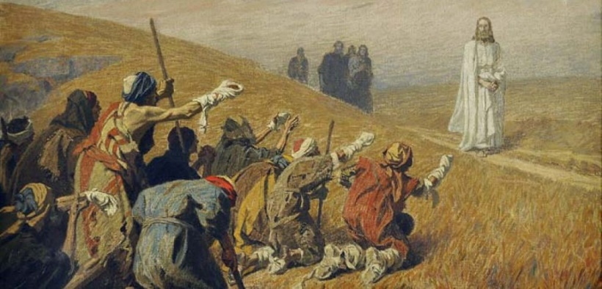
Jesus heals the ten lepers

Parish Staff
Pastor: Rev. Thomas Diaz #4
I am away this Mon. afternoon to Fri. afternoon with the priests of the diocese on retreat in Menlo Park. If it is an emergency, please phone 707 889-0549 Office Manager: Chris Giacometti: #1
Mass times: 2
Youth Faith Formation: Jennifer Bedoka #3
Executive Board: Tony Madia/Chairperson, Linda Biondini/Vice Chairperson, Katie Chase, Larry Ruminson, Julie La Plante

SACRAMENTS AND DEVOTIONS THIS WEEK
Reconciliation: Sundays: 9:45-10:15am
Marriage: One year notice to the pastor.
Infant Baptism: 1month notice. Preparation TBA.
Anointing of the Sick: Please call Fr. Tom. Usually, it is celebrated after the 10:30 Sunday Mass next to the St. Josep Joseph statue.
The Rosary: ½ hr. before Mass on Mon and Fri
Divine Mercy Chaplet: Not this week.
Exposition and Benediction: Not this week.
Mass Schedule and Intentions
Sat/Oct. 11 4 +Bridget Hynes
Sun/Oct.12 8:30 People of the Parish
10:30 +Abel Sagon
Mon/Oct.13 8:15 +Marcelina Morales
No Masses as priest are on retreat
Fri/Oct. 17 5pm. Int Charles McCollum
Sat/ Oct.18 4 +Pete Callinan
Sun/ Oct.19 8:30 People of the Parish
10:30 +Abel Sagon
12:15 Mass of the Filipino Saints

Please pray for the health intentions for: Sherman Chan, Gus Chang, Mary Couto, Patrick Dempsey, Marcella Dorado, Anthony Eger, Evelyn Estrella, Jeanne Fields, Louise Galassi, Dave Grundman, Theresa M, Nancy Keegan, Patricia Lauterjung, Kelly Limberg, Frank Manhoso, Charles Mc Collum, Larry Ng, Robert Perrill, Mary Piccioni, Lisa Rivas, Robert Scarpone, Kathleen Schick, Dominique and Cecilia Tarrant, Jessica Thompson, Malik Whitehorse. If you want a name on the list, please call the office.
Weekly Events Sun/12, 1pm. Welcoming Church/Hall Sun/19, 9:30am. SVDP Mtg./Cl
Parish Stewardship: October 5th&6th $5,286. The 2nd collection today is for Building Maintenance. The 2nd collection next weekend is split between Foreign Missions, a day set aside for the Catholic Church worldwide to renew its commitment to missionary movements, coordinated by the Pontifical Mission Societies. It is celebrated every year on the second-to-last Sunday of October and serves as an important occasion for the Church to teach the significance of giving, particularly in support of missions around the world and the Campaign for Human Development which is a national anti-poverty program of the U.S. Catholic Bishops, working to carry out the mission of Jesus Christ "... to bring glad tidings to the poor ... liberty to captives ... sight to the blind.

Last Sunday’s Homily
- How great is your Faith? Can you move mountains with it?
- There is always room to grow in your faith.
- Do you do things for the Lord out of obligation…Wrong answer.
- We should love the Lord and our neighbor out of love of God. This will make our faith grow.

Sunday Readings Reading I: 2 Kings 5:14-17, Reading II: 2 Timothy 2:8-13, Gospel: Luke 17:11-19
Our People In the Gospel Reading, Jesus cleanses ten lepers, but only one of them turns back to thank Jesus. That one is a Samaritan.
Samaritans aren’t really part of God’s people. They were separated from God’s people earlier in their history.
By loving the Samaritan leper and the Greek woman, the Lord found his own people everywhere.
In a different gospel reading (Matt.15:24; see also Mark 7:27), Jesus tells a Greek woman in Sidon, who persists in her requests for him to heal her daughter, that he was sent only to the lost sheep of Israel. Greeks are not part of God’s people either; they are even more outsiders than Samaritans are.
But here is an odd thing to notice: Jesus does after all heal the daughter of the Greek woman. He cured the Samaritan leper too.
So was Jesus confused when he said he was sent only to the lost sheep of Israel? Or, if his job really is to minister only to his own people, then why did he give such powerful gifts of healing, such tender care, to the Samaritan leper and to the Greek woman? After all, they aren’t part of his people. And he said he was sent only to the lost sheep of Israel.
The solution to this puzzle lies in the First Reading. Namaan, the leper who comes to Elisha, the Israelite prophet, to be healed, is a Syrian. Not only are Syrians not part of God’s people; they are in fact among the enemies of God’s people. They worship an alien God. But Elisha heals Namaan anyway.
And then look what happens. Namaan the leper asks if Elisha will give him some dirt to build an altar to Elisha’s God. When Elisha healed him, Namaan became committed to the true God. He wants dirt from Israel for an altar so that he can worship the God of Israel when he goes home to Syria. So Namaan comes to Elisha as a Syrian, but he leaves Elisha as a worshiper of the Lord.
A similar point holds of the Samaritan leper, and even of the woman in Sidon. They each become one of Jesus’ own, because of Jesus’ care for them. Your faith has saved you, Jesus says to the Samaritan when he returns to Jesus. To the Greek woman in Sidon who won’t leave him, Jesus says, “Great is your faith!” (Mt 15:28)
In doing a miracle for the Greek woman in Sidon, then, Jesus was in fact caring only for the lost sheep of Israel. By loving the Samaritan leper and the Greek woman, the Lord found his own people everywhere.
The lesson for us is clear, isn’t it? Treat him with gentleness and care, and the person in front of you, hostile to all you hold dear, may in the end turn out to be one of the Lord’s own people.
Eleonore Stump
Discussion Question: Do you take note when God pours grace into your life? Are you grateful?

Family Connection
Children fluctuate between moments of deep, heartfelt gratitude and an attitude of entitlement. These fluctuations are normal. Among our tasks as parents is to help foster the gift of gratitude, particularly gratitude to God for all God's goodness to us.
Read today's Gospel, Luke 17:11-19. Make a poster showing some of the gifts from God to your family. Display this poster in a prominent place and, as a family, write a prayer of thanksgiving for all of God's goodness to you.

Faith Formation Ministry
Quote of the Week
“Listen and Attend with the ear of your heart.”

Saint Benedict
Thank you for supporting our youth group at Mountain Mike’s at our first Dine and Donate for the year!
Sunday, October 12th
9:30 am 2nd Year Confirmation/CL
10:30 am Children’s Liturgy of the Word
5-6:30 pm 1st Year Confirmation/CL
Wednesday, October 15th
3-4:30 pm 1st and 2nd Year 1st Communion Classes
3-4:30 pm CGS Level 3/LG Atrium
Friday, October 17th
6pm Bible Trivia – Opened to all parishioners
Saturday, October 18th
8:15am to 1 pm Community Service at Forget Me Not Farm Children’s Services
Sunday, October 19th
9:30 am 2nd Year Confirmation/CL
10:30 am Children’s Liturgy of the Word
5-6:30 pm Youth Group/Hall

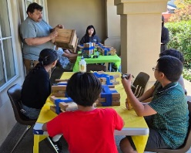
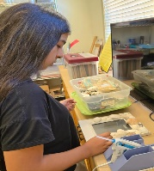
Thank you to the youth that came to our craft making event last week for the SES Craft Fair in Nov.! A big thank you to Pedro Pardo for helping the kids build planters and our helpers: Parents: Sandra Jaime ,Mirium and Pedro Cruz, and Erika Espinoza. Youth: Blake, Natalie, Jaylan, Jacob, Kevin, Mateo, Sadie, Brianna, Carissa, Lili, and Yulissa!
Join us at our next gathering!

October 17th
6pm. All are welcome to join us for Bible Trivia
Email sesreled@gmail.com if interested in joining us!
October 25th
11am to 1pm Holiday items and Dog Treats
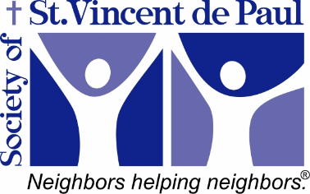
On October 25th and 26th, there will be a second collection in support of the St. Vincent DePaul Society at our parish

Funds collected on October 25th and 26th will be used to support 30 to 40 clients, to purchase food that we will deliver to them each month, along with Christmas and Easter Meals.
- People we serve are: Disabled individuals,
Veterans, Families. A total of 120-140 individuals receive food each month from our Society.
- Food delivered is purchased from the Redwood Empire Food Bank and other vendors.
- Items purchased are: Dry goods, Canned goods, Breads, Fresh Vegetables Various frozen meat products
- About 1,400 lbs. of food items are delivered each month, which equates to 691 meals, or 17 meals per client.
Our forecast for helping our clients for the next 12 months is to deliver to 360 clients and provide 90 Christmas and 60 Easter meals.
Your gift to the Society will show that you are indeed a disciple of Jesus, as it will enable us to bring your love to our neighbors in need.
With your help, we are doing God's work, one family at a time.
God bless you and thank you for your support.
- Checks for this collection are to be made out to St. Elizabeth Ann Seton and will then be transferred to the St. Elizabeth Ann Seton Society of St. Vincent de Paul of Rohnert Park.

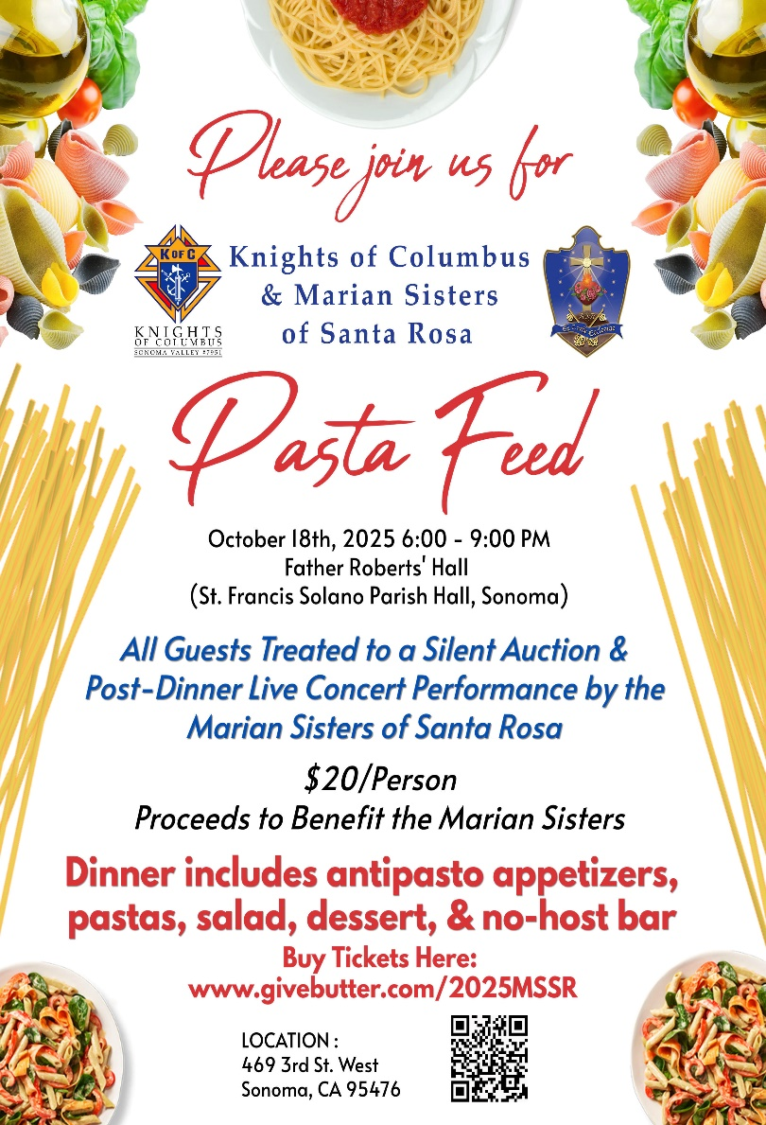

Sunday, October 19th 12:15pm at St. Elizabeth Ann Seton, Rohnert Park
Celebrating two Filipino Saints.
Join us in honoring the faith of
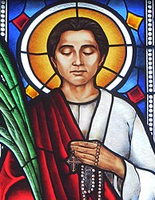
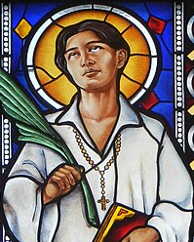
St. Lorenzo Ruiz and St. Pedro Calungsod

at a special Mass celebrated by Fr. Rowell Gumalay. A simple reception will follow in the parish hall hosted by the Filipino-American Society of St. Elizabeth Seton Church. For more information contact: sesreled@gmail.com


The Carmelite House of Prayer in Oakville (located on the Oakville Grade between Highways 12 & 29) will be holding its Rosary Procession, Benediction, and Crowning of the Blessed Virgin Mary on Sunday, October 19, at 2:00 p.m.
Refreshments will be served following the ceremony.

Pastor’s Corner
Please read the red section on the cover of the bulletin.
Please pray for us priests on retreat this week.
I am finding cigarette butts in the parking lot. If you see someone smoking tell them that the parish facility is NO SMOKING.
We are in need for someone new to coordinate the prayer group in praying for the sick. I thank Char Mayclin who has done it in the past.
We are in need of extraordinary ministers of the Eucharist to bring Holy Communion to the sick and to the adult Retirement Centers of Cogir and Clearwater.


Ministry Schedule October 11th & 12th
4pm
Readers: Tony Sacramento, Tony Madia
EMS: Linda Mish, Janice Dyer, Dianne Foppoli
Ushers: Tony & Beth Turegano
Greeters: Ron & Debra Ciarasso
8:30am
Readers: Liz Ritchie, Maria Van Anne
EMS: Diane Cook, Mary Thayer, Dave Grundman
Ushers: Liz Chang, Diane Cook
Greeters: Larry & Jo Ruminson
10:30am
Readers: Linda Biondini, Marie Horwitz
EMS: Nora John, Giovanna DeSinone, Nativity Mata
Ushers: Sally Shami, Dianne Foppoli
Greeters: Fred & Janet Adam
October 18th & 19th
4pm
Readers: Linda Anderson, Evelyn Estrella
EMS: Jovita Bishop, Luisa Bustillos, Tony Madia
Ushers: Mark & Selina Johnson
Greeters: Pat Yates, Sally Shami
8:30am
Readers: Phillip Alvarado, X
EMS: Dave Grundman, Mary Thayer, Diane Cook
Ushers; Remie Alinas, Mary Thayer
Greeters: Alan & Caroline Kalaw
10:30am
Readers: Fred Adam, Mary Denson
EMS: Nora John, Vickie Gregorio, Giovanna DeSimone
Ushers: Scott & Mila Morrical
Greeters: Giovanna DeSimone, Nativity Mata

Who would like a project to put up a cyclone gate at the entrance of the church. People are coming in after 9 pm and later, to who knows what. We need a little more security, so I do not have to approach the people and remind them that this is private property. If you are interested, please give Fr. Tom a call. The gates would not be locked just closed at night at a certain time.

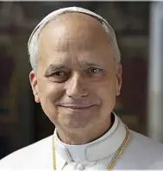
Pope Leo XIV shunned the “degrading” media practice of posting “clickbait” online at a Vatican conference with dozens of journalists Thursday. “Communication must be freed from the misguided thinking that corrupts it, from unfair competition and the degrading practice of so-called clickbait,” the pope declared to roughly 150 members of the newswire group Minds International. Along with condemning clickbait — a form of sensationalist headline writing designed to rope in readers — as practice, the head of the Catholic Church praised the work reporters are doing from the war-torn front lines of Gaza and Ukraine. “Free access to information is a pillar that upholds the edifice of our societies, and for this reason, we are called to defend and guarantee it,” he said. “Current events call for particular discernment and responsibility, and it is clear that the media has a crucial role in forming consciences and helping critical thinking.” Pope Leo has hailed journalism as “a public good that we all should protect” during the first six months of his papacy.
Prayer for Truth and Integrity in Media
Dear Heavenly Father, We come before you with a prayer for truth and integrity in the media. We ask that you guide and inspire journalists, reporters, and all media professionals to seek and uphold the truth in their work. May they be unwavering in their commitment to accuracy, fairness, and unbiased reporting. Give them the courage to resist sensationalism and the wisdom to discern fact from fiction. Amen.

