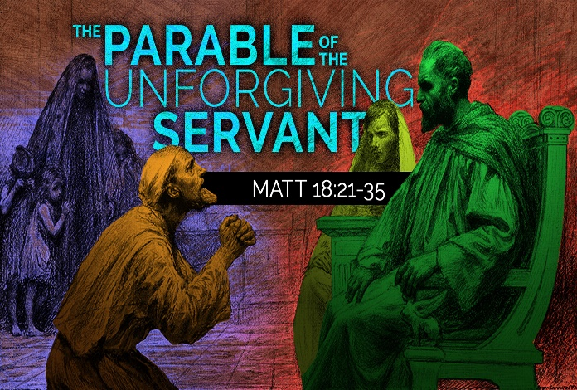
St. Elizabeth Ann Seton Catholic Church 4595 Snyder Lane Rohnert Park, CA 94928 (707) 585-3708 Website:www.Stelizabethrp.com E-Mail stelizseton@sbcglobal.net Office Hours: Tue.- Fri. 9am - 1pm The Church is open daily 7:30am – 7:30pm September 13, 2026 24th Sunday in Ordinary Time
- Related search Parish Staff
Pastor: Rev. Thomas Diaz #4 Office Manager: Chris Giacometti: #1
Mass times: #2
Youth Faith Formation: Jennifer Bedoka #3
Executive Board: Tony Madia/Chairperson, Linda Biondini/Vice Chairperson, Katie Chase, Larry Ruminson, Diane Colbrook
Floral Decorations: Cesira Rantissi Heric
(707)338-3959
Sacraments and Devotions
Reconciliation: Sundays: 9:45-10:15am,
Thusdays: 1-1:30
Marriage: One year notice to the pastor.
Infant Baptism: 1 month notice. The next preparation session is on Sept. 20th noon-2pm.
You must register in the office for the class.
Anointing of the Sick: Please call Fr. Tom. Usually, it is celebrated after 10:30 Sunday Mass
The Rosary: ½ hr. before weekday Masses.
Divine Chaplet: Tuesdays after the12:15 Mass
Exposition & Benediction: Thu.12:45-1:45pm.
Adult Initiation Sessions: Starting Oct 14^{th,} 6pm,
Mass Schedule and Intentions Sat/Sep 12 4pm Ints. of Joe Arrigoni Sun/Sep 13 8:30am +Abel Sagon 10:30am People of the Parish Mon/Sep 14 8:15am Ints. of our Seminarians Tue/Sep 15 12:15pm +Salud & Joaquinito Dayanghirang Wed/Sep 16 8:15am +Jose Araiza Thu/Sep 17 12:15pm +Ronald Kimball Fri/Sep 18 8:15am For All Priests Sat/Sep 19 4pm +Felipe & Nel Galvez Sun/Sep 20 8:30am People of the Paris 10:30am +Paul Morales
Stewardship for September 6th
Plate: $4,980. Ouch! We need $5,000 to pay our bills but Thank You! The 2nd collection today is for Building Maintenance. The 2nd collection next weekend is for seminary formation for our five seminarians.

Events for the Week Sun/Sep 13 10:30am Children’s Liturgy of the Word Noon Parish Picnic Tue/Sep 15 6pm Pastoral Council Mtg/Hall Wed/Sep 16 1:30pm Craft Faire Mtg/Hall Sun/Sep 20 9:30am St. Vincent De Paul Mtg/Hall 11:30am Hispanic Ministry Mtg/Hall
Last Sunday’s Homily Highlights
- How do you confront others?
- Do you do it with kindness or anger?
- Jesus wants us to live in peace.
- We need to stand up and address the wrong of others.
- Let your motive be love of God and neighbor when you need to confront someone.
Sunday Scripture Readings Reading I: Sirach 27:30-28:7, Reading II: Romans 14:7-9, Gospel: Matthew 18:21-35. Sunday Scripture Reflection

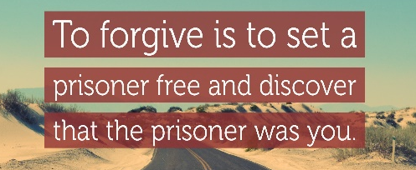
This Sunday is about forgiveness, and most of us have something to learn about this important act. In the Book of Sirach, our First Reading, tells how awful wrath and anger are, and how the sinner “hugs them tight,” a wonderful image. Release them and let them go, it says. The Psalm speaks beautifully about God’s absolving love: God is kind and merciful, slow to anger, rich in compassion. The Second Reading says we ought to live not for ourselves but for others. We should imitate God. When we live for the Lord, it says, we will also be graced to die for the Lord. Forgiveness is a major ingredient of living for God and for others. People do not always do right, and we need to forgive them as God does. Forgiveness is the gift and the goal. But what does it consist of? Our culture has some pretty diverse ideas about this. For some it is a condescending act performed only by a person who is higher than another—a King or Queen or a judge or a boss or a media star—someone who leans down to grant pardon. For others it means “I can forgive but I can never forget.” Perhaps this means, I will remain angry forever, but I will never act upon it. Such a stance can include an uncomfortable attitude: “I will choke back my hurt and anger by a sheer act of the will. I may have been savaged by someone, but I will not display it in my reaction.” On Easter Sunday of 1960, that seer of truth and lover of God, Dag Hammarskjold, wrote an interpretation that moved me: Forgiveness breaks the chain of causality because he who “forgives” you—out of love—takes upon himself the consequences of what you have done. Forgiveness, therefore, always entails a sacrifice. There is a price you must pay for your own liberation. Since it has come through another’s sacrifice, you in turn must be willing to liberate in the same way, in spite of the consequences to yourself. You absorb them, if doing so truly flows out of love. (from Hammarskjold, Markings, p. 197) Let us apply these insights to the Gospel. There, Jesus tells a long and involved parable about a servant who is pardoned by the master but then goes out and refuses, viciously, to forgive his own fellow servants,about six lines from the end the owner of the vineyard calls him a “wicked servant” and says, “should you not have had pity on your fellow servant, as I had pity on you?” What is the lesson? That the deepest motivation for forgiveness is loving gratitude. If someone has forgiven me out of love, then my authentic reaction will be deep appreciation. I will want spontaneously to pass the gift on. It follows that if God has forgiven me, I will want to give to anyone else the same liberation I have received. By doing so you or I halt the chain of causality and pass along love instead of hate. As we dwell in Christ’s presence this Sunday, especially if we are able to receive communion, let us sense his forgiving love, signified so deeply in the sacrament. Let us allow our gratitude to flow to others. John Foley, SJ.

Discussion Question: Is it harder for you to forgive someone else or to ask someone for forgiveness? Sunday Family Connection Children learn to trust God's mercy and forgiveness when they experience forgiveness from those closest to them. We hope that we model God's love and forgiveness within our family life. Today's Gospel reminds us that forgiveness is measured by its quality more than its quantity. Invite your family to consider some recent times when family members sought forgiveness of another. Ask if there were any statements made that put conditions on our forgiveness such as “I will play this game with you if you apologize for knocking over my blocks” or “I will accept your apology after you clean up your room.” Do we sometimes “keep count” or put conditions on our forgiveness of one another? This is something we may be doing without realizing it.
Please pray this week for: Joe Arrigoni, Bi Bi Ballesteros, Giselle Ballion, Catherine Delara, Diva & Gaba Delara, Giovanna DeSimone, John Diaz. Marcella Dorado, Maryann Eger, Marcus Esplada, Jim Estrella, Rosita Faltado, Amanda Fernandez, Janet Fenstermacher, Kathy & Cedric Fontana, Carl Hilton, Nancy Keegan, Sue Kennedy, Trinidad Legasti, Frank Manhoso, Ruth McAllister, Judith Miller, Joseph Patrick, Mary Piccioni, Vivian Pruett, Emi Jade Przyborowski, Linda Sime, Cecilia Tarrant, Diane Thrailkill, Jim Turegano, Tiffany Valentine, Kenneth Wagy, and Steve Werle. To put a name on the list, please call the office.
Please pray for the soul of Maryann Vossbrink and keep her family in your prayers.

Quote of the Week
“Grandparents are the wisdom of the family, they are the wisdom of a people.” Pope Francis

If you would you like to learn more and walk with our older youth as they learn more about their faith? We will have a workshop later in September. Stay tuned for details.
Faith Formation Schedule
Sun., September 13th
9:30am First Year Confirmation Parent Mtg/CL
10:30am Children’s Liturgy of the Word/ Atrium
Wed., September 16th
3:30pm First Communion Level 1/CL
3:30pm First Communion Level 2/CL
Sun., September 20th
9:30am 1st Year Confirmation/CL
5pm 2nd Year Confirmation Level 2/CL
Tues., October 13th
CGS
3:30pm Level 1 Ages 3-6 3:30-5pm/ L1 Atrium
All Parents, Catechists and Aides, please check your emails regarding Signup Genius.
Mass Cards will be available after Masses on September 13th. Please get your stamp card stamped starting 9/13..
Questions? Email sesreled@gmail.com or text 707-888-9672

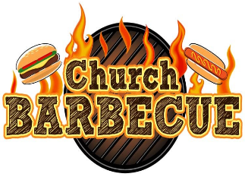
Today at 11:30 am!
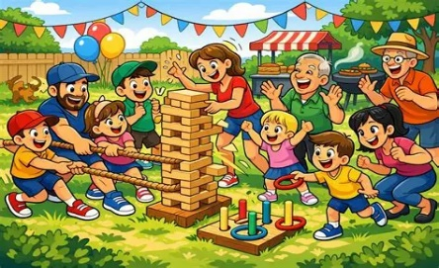
Here on our grounds!
Food, Fun, & Games For All!

Special Liturgical Dates this Week

Mon. Sept. 14th. The Exaltation of the Holy Cross
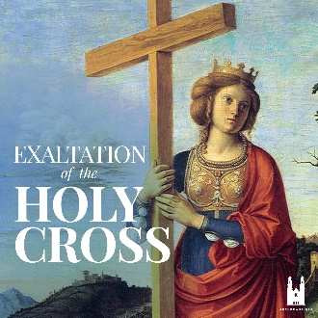
Early in the fourth century, Saint Helena, mother of the Roman Emperor Constantine, went to Jerusalem in search of the holy places of Christ’s life. She razed the second-century Temple of Aphrodite, which tradition held was built over the Savior’s tomb, and her son built the Basilica of the Holy Sepulcher on that spot. During the excavation, workers found three crosses. Legend has it that the one on which Jesus died was identified when its touch healed a dying woman.
The cross immediately became an object of veneration. At a Good Friday celebration in Jerusalem toward the end of the fourth century, according to an eyewitness, the wood was taken out of its silver container and placed on a table together with the inscription Pilate ordered placed above Jesus’ head: Then “all the people pass through one by one; all of them bow down, touching the cross and the inscription, first with their foreheads, then with their eyes; and, after kissing the cross, they move on.”
To this day, the Eastern Churches, Catholic and Orthodox alike, celebrate the Exaltation of the Holy Cross on the September anniversary of the basilica’s dedication. The feast entered the Western calendar in the seventh century after Emperor Heraclius recovered the cross from the Persians, who had carried it off in 614, 15 years earlier. According to the story, the emperor intended to carry the cross back into Jerusalem himself, but was unable to move forward until he took off his imperial garb and became a barefoot pilgrim.
We will have mass at 8:15am. on Monday

Tue. Sept 15th, The Seven Sorrows of Mary
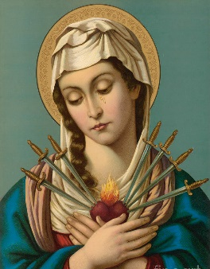
  - The Prophecy of Simeon. Sorrow as sharp as a sword shall pierce Mary’s heart
  - The Flight Into Egypt. Herod the King seeks to kill the Child..
  - The Loss of the Child Jesus in the Temple.
  - Mary Meets Jesus on the Way to Calvary.
  - Mary at the foot of the cross. Her beloved Son is dying, and she shares in His suffering.
  - Jesus body is taken down from the Cross. and Mary receives It in her arms.
  - Mary watches as the great stone to the sepulcher is rolled. It is the end.
SAVE THE DATES


St. Vincent de Paul College Prep Admissions News
Open House - Monday, October 19th at 6:15pm. Your family is invited to explore St. Vincent de Paul College Prep. Learn how your child too can benefit from the 21st century education we offer in a small but diverse learning community. Our skills-based and personalized approach rests on the intellectual and spiritual foundation of our 108 year Catholic school tradition. Another great way for prospective 9th - 12th graders to get to know SV is to sign up for a school day visit! Contact Mrs. Kerry Pedersen for more information at kpedersen@svhs-pet.org.




Join the festivities at the Rohnert Park Founder’s Day Celebration 9/26/2026
11-3 at the Rohnert Park Community Center.
Enter the Car Show!
Enter the Rib Contest!
Enter the Chili Cook-off!
Enter the parade!
For details contact Giovanna Desimone giovannadesimone@aol.com
or Jennifer Bedoka sesreled@gmail.com!

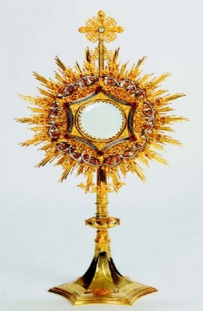
Sonoma State University Newman Center Eucharistic Conference
Encountering Christ in the Eucharist Learning, Loving, and Living the Truth. Fri & Sat, Oct 23-25th Sonoma State University Warren Auditorium Tickets $60. Look to the bulletin board
for QR Code and scan.
For more info: 707 696-2171


The Women’s Guild


4th Annual Craft Fair
Saturday, November 7th, 10am-4pm Sunday, November 8th, 9am-1pm
More info later.

Social Justice Ministry

The Social Justice Ministry will conduct a clothing drive for the Unsheltered Friends Outreach (UFO) and it will begin on October 3rd and end November 1st. The needs are for adults only, about 75% are men. There is a need for boots, men’s shoes, pants, T-shirts and long-sleeved shirts (the types of clothes that can be layered). Please no formal attire. Our parish has shown great generosity to the UFO. God bless you! The Social Justice Ministry Pastor’s Corner I want to thank: Suzanne Cossette, Elizabeth Black, Selena and Sally Shami for helping me make the Macaroni Salads for the picnic. TERMITES!!!!!!!!!!!!!!!!!!!!!!!!!!!!!!!!! The parish hall has termites and so the hall will be fumigated in a few weeks. That means it will have a tent over itfor fumigation I am glad we have a building maintenance account in the parish as the bill will be over $18,000. I wish I knew about this last week as I would have publicized it as we have a Building Maintenance 2nd collection this weekend and so be generous next month when you write your checks. We also are looking at bids for cameras for security and they are not cheap. Thus is because of the fountain vandalism last month. In looking over the hall with the Clark exterminator I looked into the table storage room and I was not happy as it was a mess! I will be bringing up the matter at the Pastoral Council this week. Kitchen Renovation: We are looking for a plumber who can solve many of the problems in the kitchen at this time. We have about $80,000 for the renovations so far. Support SCRIP as it is paying for some of the landscaping taking place. I would ask that people not leave prayer booklets (many times outdated as we are in September, along with holy cards, etc.. Please give them away personally to your friends.
Ministry Schedule September 19th & 20th
4:00pm Mass
Readers: Liz Ritchie, Tony Sacramento
EMS: Joanne Bishop, Luisa Bustillos, Bill Yates
Ushers: Mark & Selina Johnson
Greeters: Luisa Bustillos, Pat Yates
8:30am Mass
Readers: Teresa Fonseca, Dolores Sanchez
EMS: Diane Cook, Patty Ramos, Mary Thayer
Ushers: Remie Alinas, Barry Goff
Greeters: Larry & Jo Ruminson
10:30am Mass
Readers: Milagros Morrical & Scott Morrical
EMS: Lorraine Datu, Giovanna Desimone, Victoria Gregorio
Ushers: Agustine Gonzalez, Sally Shami
Greeters: Fred & Janet Adam

Saying of the Week
"Love is our true destiny. We do not find the meaning of life by ourselves alone. We find it with another."
Thomas Merton
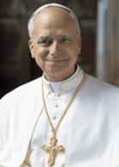
Pope Leo News
Pope Leo XIV will not visit the United States in 2026 due to tensions with the Trump administration and disagreements over U.S. policies on immigration and foreign affairs.
Upcoming Visits and Events
- Lourdes, France (Sept. 26–27, 2026): The Lourdes Shrine has confirmed 150,000 registered pilgrims will attend Pope Leo XIV’s visit, marking the 150th anniversary of the Marian apparitions. He will arrive in Paris on Sept. 26 and celebrate Mass at the shrine on Sept. 27
- Peru (Nov. 11–17, 2026): The Pope will return to his adopted home country for an 11-day South American trip. In Callao, Lima’s port city,

The Santa Rosa Diocese Religious Education Congress, sept 26th. Please look to bulletin board for more info.

